DNA structure
http://tigger.uic.edu/classes/phys/phys461/phys450/ANJUM04/
DNA is usually a double-helix and has two strands running in opposite directions. (There are some examples of viral DNA which are single-stranded). Each chain is a polymer of subunits called nucleotides (hence the name polynucleotide).
Each strand has a backbone made up of (deoxy-ribose) sugar molecules linked together by phosphate groups. The 3' C of a sugar molecule is connected through a phosphate group to the 5' C of the next sugar. This linkage is also called 3'-5' phosphodiester linkage. All DNA strands are read from the 5' to the 3' end where the 5' end terminates in a phosphate group and the 3' end terminates in a sugar molecule.
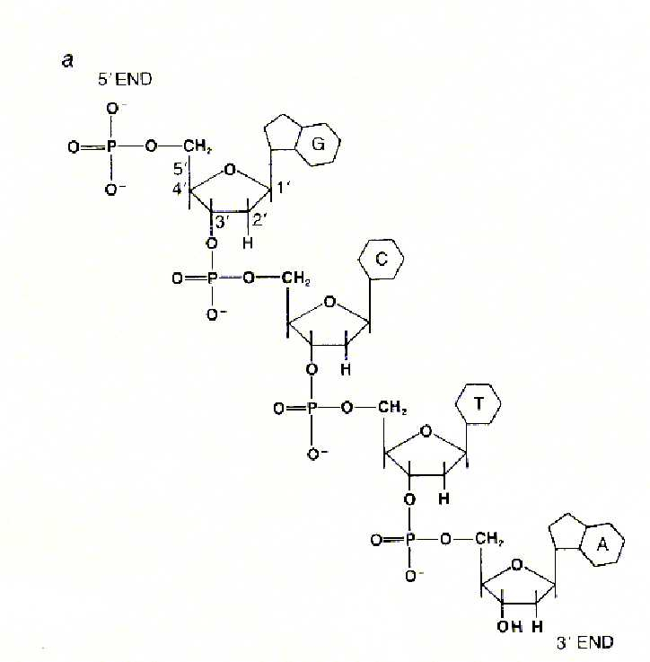
Each sugar molecule is covalently linked to one of 4 possible bases (Adenine, Guanine, Cytosine and Thymine). A and G are double-ringed larger molecules (called purines); C and T are single-ringed smaller molecules (called pyrimidines).
In the double-stranded DNA, the two strands run in opposite directions and the bases pair up such that A always pairs with T and G always pairs with C. The A-T base-pair has 2 hydrogen bonds and the G-C base-pair has 3 hydrogen bonds. The G-C interaction is therefore stronger (by about 30%) than A-T, and A-T rich regions of DNA are more prone to thermal fluctuations.
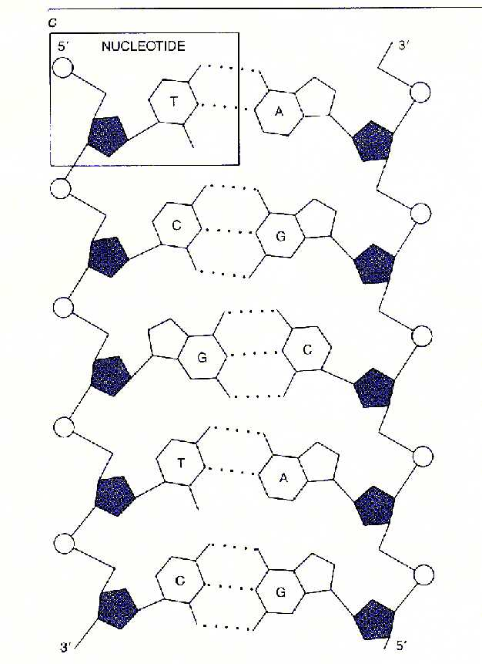
The bases are oriented perpendicular to the helix axis. They are hydrophobic in the direction perpendicular to the plane of the bases (cannot form hydrogen bonds with water). The interaction energy between two bases in a double-helical structure is therefore a combination of hydrogen-bonding between complementary bases, and hydrophobic interactions between the neighboring stacks of base-pairs.
Even in the single-stranded state, the bases prefer to be stacked (like the steps of a spiral staircase).


