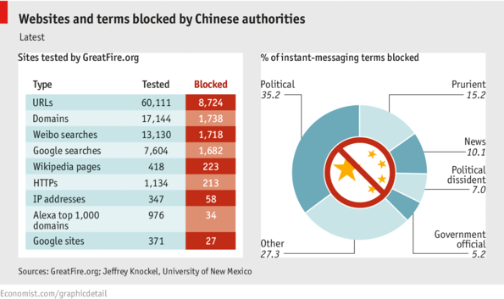
Source: Uploaded from: http://www.economist.com/blogs/graphicdetail/2013/04/daily-chart-3

