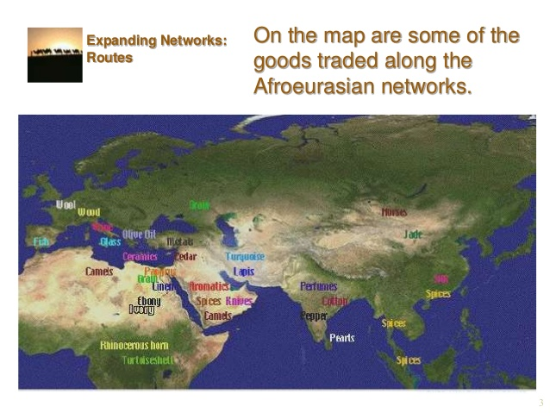
Ancient World- Silk Road along the Afro-Eurasian World Zone
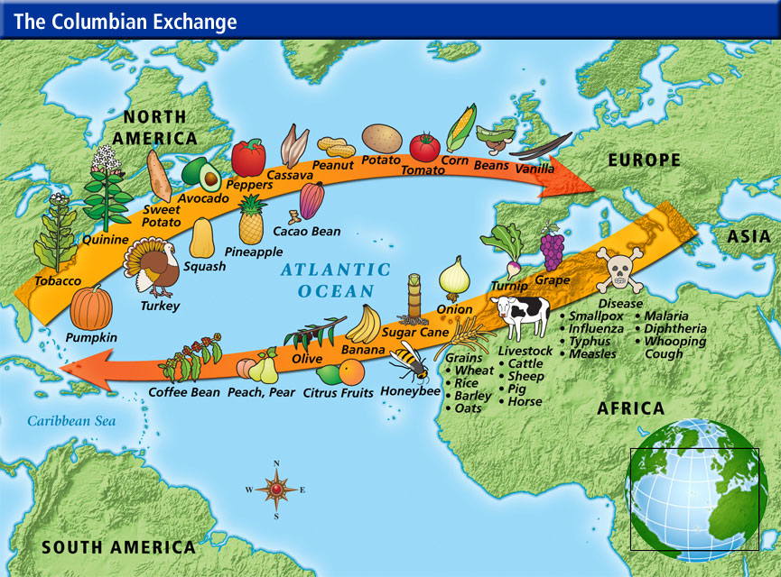
Columbian Exchange

