Barbarian Tribes of Europe
Rome was defeated by several barbarian tribes over a period of time. These tribes are the ancestral people of much of Europe and Asia Minor. We will spend today learning about these people.
- List of tribes

- Angles
- Saxons
- Jutes
- Franks
- Visigoths
- Vandals
- Ostrogoth
- Huns
- Celts
- Picts

- Identify on this map of Europe where these groups resided. Make a key and give a different color for each of the tribes.

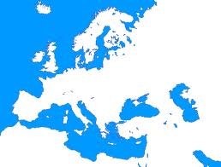

- Research the cultures of these ten tribes. What were they like? What did they value? What was their lifestyle like?

- Angles

- Saxons

- Jutes

- Franks

- Visigoths

- Vandals

- Ostrogoth

- Huns (Include the biography of Attila the Hun)

- Celts

- Picts

- Answer the final question on a separate sheet of paper: “Which of these tribes was most significant to world history?” Make a claim and buttress it with at least three pieces of evidence. For Example: In my opinion, the Celts are most significant to world history based upon x, y, and z. PROVIDE CITATIONS OF YOUR THREE SOURCES.

