Films Shown During This Course:
We will be watching three full-length films during this course. Our first film will be, “The Truman Show” during the epistemology unit.
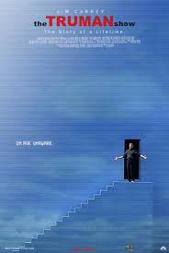
About the Film:
This 1998 film was groundbreaking when it was released and continues to have significance to this day, especially in the realm of social sciences. There are aspects of philosophy, psychology, and sociology evident throughout the film. Starring Jim Carrey, Laura Linney, and Ed Harris, it shows a reality show where an artificial word is created for Truman Burbank and charts his path to truth and enlightenment. It is also my favorite movie of all-time (sharing my bias).
The second is, “Finding Joe” during the aesthetics unit.
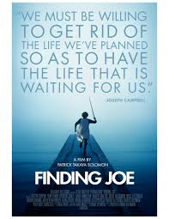
About the Film:
In the early 20th century, while studying world mythology, Joseph Campbell discovered a pattern hidden in every story ever told and he called it “the hero’s journey”. A truly inspirational film, FINDING JOE takes us on the ultimate hero’s journey: the journey of self-discovery. As you slay dragons and uncover treasures, you just may find that the Holy Grail you seek is closer than you think.

We will also watch the film, “Kumare” to begin the unit on Metaphysics.
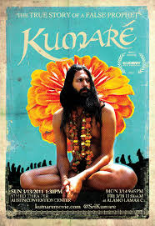

About the Film:
Kumaré is a feature documentary film about the time filmmaker Vikram Gandhi impersonated a fake guru and built a following of real people. Winner of the Audience Award for Best Documentary at SXSW 2011, it implores us to explore the premises behind our metaphysical and religious believes. It also poses an obvious ethical question on whether Gandhi’s methods were morally-sound.

