Lenses and “stuff” you should know about them
*Lenses are transparent ya’ll. Mirrors are opaque. Different, yes? Or are they?
Concave lenses (diverging lenses) – Make light rays diverge (duh!).
Act like a convex mirror in that images are always Virtual, upright and smaller than the object.
i.e. viewfinder in camera, glasses or contacts to correct nearsightedness
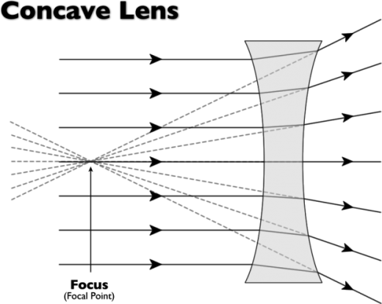
https://www.google.com/search?site=&tbm=isch&source=hp&biw=1366&bih=641&q=picture+of+lenses+and+focal+points&oq=picture+of+lenses+and+focal+points&gs_l=img.3...2428.7788.0.7868.34.17.0.17.3.0.164.1697.12j5.17.0....0...1ac.1.64.img..2.17.1442...0j0i30j0i8i30.dz1cCIiERwg#imgrc=ugqWKCOAg3eN1M%3A
Convex lenses (converging lenses) - Make light rays converge (duh!) Can concentrate light and build up thermal energy to burn stuff. Don’t do this – dangerous!
Act like a concave mirror because images can be inverted or upright so they are real or virtual. They can be bigger or smaller than the object, depending on whether object is inside or outside the focal point. Remember that lenses have 2 focal points, unlike mirrors, because they are transparent and light can go through them. There is one focal point on one side of the lens and another focal point on the other side of the lens!
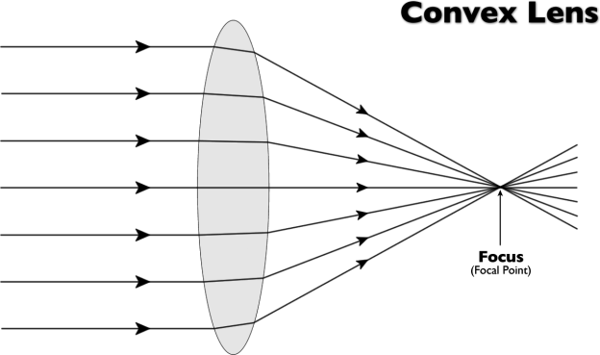
https://www.google.com/search?site=&tbm=isch&source=hp&biw=1366&bih=641&q=picture+of+lenses+and+focal+points&oq=picture+of+lenses+and+focal+points&gs_l=img.3...2428.7788.0.7868.34.17.0.17.3.0.164.1697.12j5.17.0....0...1ac.1.64.img..2.17.1442...0j0i30j0i8i30.dz1cCIiERwg#imgrc=pJ1HGIbXJdhBiM%3A
i.e. magnifying glass, lens of eyeball, microscope lens, telescope lens, binoculars, camera lens, in glasses and contact lenses to correct farsightedness

