Origins of the Korean War
KOREA, like Germany, had been jointly occupied by Soviet and American forces at the end of World War II. The nation had been part of the Japanese empire since 1910. The end of World War II ended Japanese resistance in 1945. The Red Army (Soviet Union), which had been planning to invade Manchuria, found the way open into northern Korea as well. American troops whose original mission had been to invade Japan moved into southern Korea. The peninsula was occupied, therefore, more by accident than by design. Moscow and Washington agreed without difficulty that the 38th parallel, which split the peninsula in half, would serve as a line of demarcation pending the creation of a single Korean government and the subsequent withdrawal of occupation forces.
Those withdrawals did take place, in 1948-49, but there was no agreement on who would run the country. Instead it remained divided, with the American-supported Republic of Korea in control of the south, while the Soviet-supported Democratic Republic of Korea ruled the north. The only thing unifying the country by then was a civil war, with each side claiming to be the legitimate government and threatening to invade the other.
Neither could do so, however, without superpower support. Americans denied support to their South Korean allies, chiefly because the Truman administration had decided to remove all positions on the Asian mainland and to concentrate on the defense of Japan, Okinawa, and the Philippines. The South Korean president Syngman Rhee repeatedly sought support from Washington to liberate the north, but he never got it. One of the reasons the Americans withdrew their troops from South Korea was their fear that the unpredictable Rhee might "march north," and thus drag them into a war they did not want.
Rhee’s North Korean counterpart, Kim Il-sung, had similar designs on the south, and for a time a similar experience with his superpower sponsor. He had repeatedly sought support in Moscow for a military campaign to unify Korea, and had been repeatedly turned down—until January, 1950, when yet another request got a more encouraging response. What made the difference, it appears, was Stalin's conviction that a "second front" was now feasible in East Asia, that it could be created by proxies, thus minimizing the risk to the U.S.S.R., and that the Americans would not respond. The Truman administration had announced publicly that the American "defensive perimeter" (or sphere of influence) did not extend to South Korea. The Soviet leader then informed Kim Il-sung that "[a]ccording to information coming from the United States, . . . [t]he prevailing mood is not to interfere." Kim in turn assured Stalin that "[t]he attack will be swift and the war will he won in three days."
Stalin's "green light" to Kim Il-sung was part of the larger strategy for seizing opportunities in East Asia that he had discussed with the Chinese. Shortly after endorsing the invasion of South Korea, Stalin also encouraged Ho Chi Minh to intensify the Viet Minh offensive against the French in Indochina (Vietnam). Victories in both locations would maintain the momentum generated by communist revolution in China the previous year. They would also compensate for the setbacks the Soviet Union had encountered in Europe, and they would counter increasingly obvious American efforts to bring Japan within its system of postwar military alliances. A particular advantage of this strategy was that it would not require direct Soviet involvement. The North Koreans and the Viet Minh (in northern Vietnam) would take the initiative, operating under the pretext of unifying their respective countries. And the Chinese, still eager to legitimize their revolution by winning Stalin's approval, were more than willing to provide backup support, if and when needed.
These were the events that led to the North Korean invasion of South Korea. What Stalin had not anticipated was the effect it would have on the Americans. The unexpected attack in Korea was almost as great a shock as the one on Pearl Harbor nine years earlier. Its consequences for Washington's strategy were profound. South Korea in and of itself was of little importance to the global balance of power. The blatant invasion—across the 38th parallel, a boundary sanctioned by the United Nations—appeared to challenge the entire structure of postwar collective security. It had been just this sort of thing that had led to the collapse of international order during the 1930s, and to the subsequent outbreak of World War II. Truman hardly needed to think about what to do: "We can't let the UN down," he repeatedly told his advisers. It took his administration only hours to decide that the United States would come to the defense of South Korea, and that it would do so not just on its own authority, but under that of the United Nations too.
It was able to do so quickly for two reasons. The first was that an American army was conveniently stationed nearby, occupying Japan—a fact Stalin seems to have overlooked. The second—another oversight on Stalin's part—was that there was no Soviet representative present in the Security Council to veto United Nations action. Stalin had withdrawn some months earlier as a protest against the organization’s refusal to seat the Chinese communists. With U.N. approval the international community mobilized to counter this new threat to international security, yet another response that Moscow had not anticipated.
The response almost failed. American and South Korean troops were forced to retreat to the southeastern tip of the Korean peninsula and ready to evacuate. However, the United Nations commander, General MacArthur, surprised the North Koreans with an amphibious landing near Seoul. Soon he had trapped the North Korean army below the 38th parallel, and his forces were advancing almost unopposed into North Korea. Shocked by this sequence of events, Stalin was on the verge of accepting a lost war, even the prospect of the Americans occupying North Korea itself, which directly bordered on China and the Soviet Union: "So what," he commented wearily. "Let it be. Let the Americans be our neighbors."
There remained, though, the question of what the Chinese would do. Communist China had supported the invasion of South Korea, and had begun moving troops to the North Korean border. "We should not fail to assist the Koreans," China’s leader Mao Zedong told his advisers early in August. "We must lend them our hands in the form of sending our military volunteers there." There was concern in Washington about the possibility of Chinese intervention, and for that reason Truman ordered MacArthur not to advance all the way to the Chinese border. Shortly thereafter Mao was able to inform the Russians and the North Koreans that the Chinese would be soon corning to the rescue.
Thus it happened that, at the end of November, 1950, two armies once again confronted one another. The Chinese began to drive the American troops out of the Korean peninsula with human wave attacks, and all the advantages of surprise. Two days later MacArthur informed the Joint Chiefs of Staff: "We face an entirely new war."
Additional Notes on the Korean War
- 1950 – 1953 (Years of Fighting)
- The United Nations/United States supported South Korea
- The Soviet Union (U.S.S.R)/China supported North Korea
- Armistice is signed in 1953 – this only put an end to the fighting. An armistice is an agreement to stop fighting. It is not a peace treaty. Therefore, the Korean War is technically not over.
- The U.S. has maintained a permanent military presence in S. Korea ever since the Korean War and we are sworn to protect S. Korea in the event the war ever resumes.
- The Korean War was the test case for the Containment Policy. The goal was to see if we could fight a limited war in the hope of containing communism to where it already existed (N. Korea).

The Korean War

Stage 1: North Korea Attacks
1. When and how did the Korean War begin?

2. What recommendation was made by the United Nations?

3. What action did President Truman approve the Air Force and Navy to do?

4. Who was in charge of U.S. military forces in the Korean War? (Hint: He is a famous general from WWII)

Stage 2: Americans pushed to the Pusan perimeter
1. How did American forces fare against the N. Koreans early in the war?

Stage 3: Inchon
1. What “genius” maneuver did MacArthur call for to turn the tide of the war? Was this maneuver conducted by land or sea?

2. What two important cities were returned to American/S. Korean control as a result of MacArthur’s amphibious attack?

3. On what date did MacArthur receive permission to pursue into N. Korea?

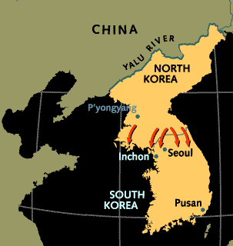

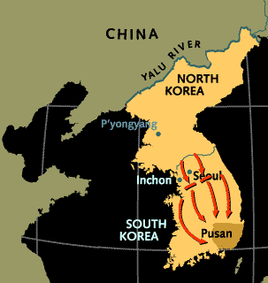

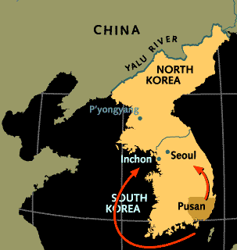

Stage 4: Approaching the Yalu
1. What country threatened to come to the aid of N. Korea if the U.S. advanced into that country?

2. On what date did the Chinese attack U.S. forces in N. Korea? How did the fighting go? On what date did the Chinese withdraw?

3. What action did MacArthur decided to take in late November?

Stage 5: An entirely new war
1. How did the Chinese respond to MacArthur’s offensive?

2. How far back were American forces driven by the Chinese and N. Koreans?

Stage 6: Stalemate
1. Along what parallel did N. Korean and U.S. forces come to a stalemate in the war?

2. Why did President Truman fire MacArthur?

3. On what date was the armistice signed that ended the fighting in the Korean War?

