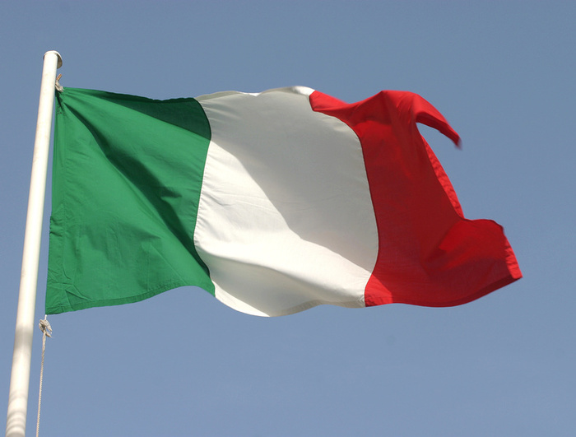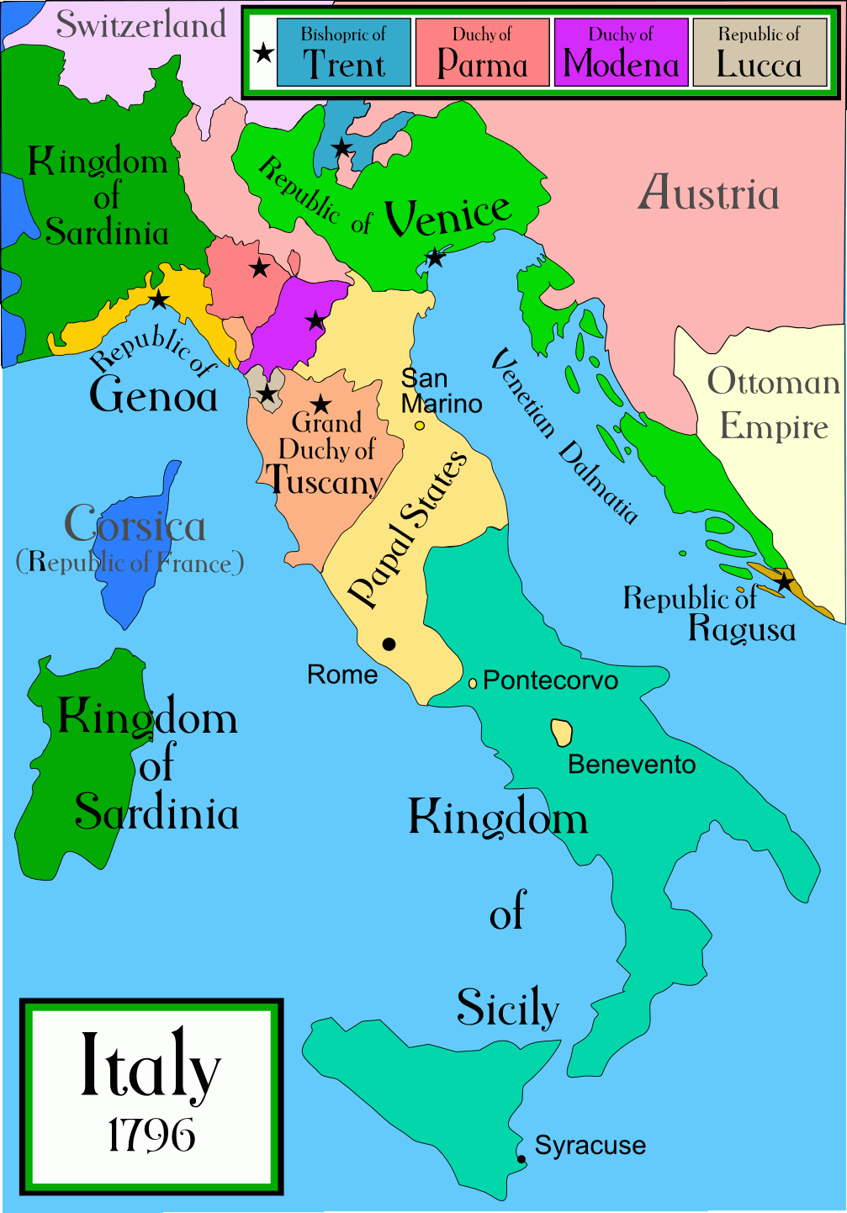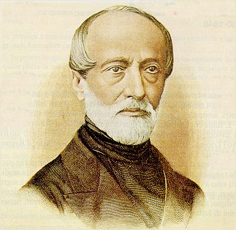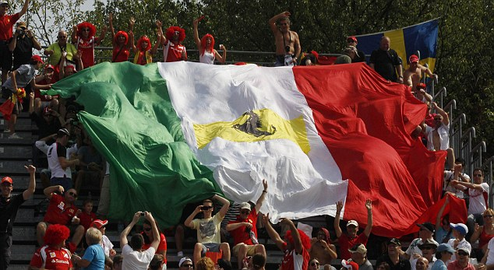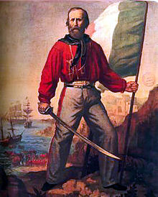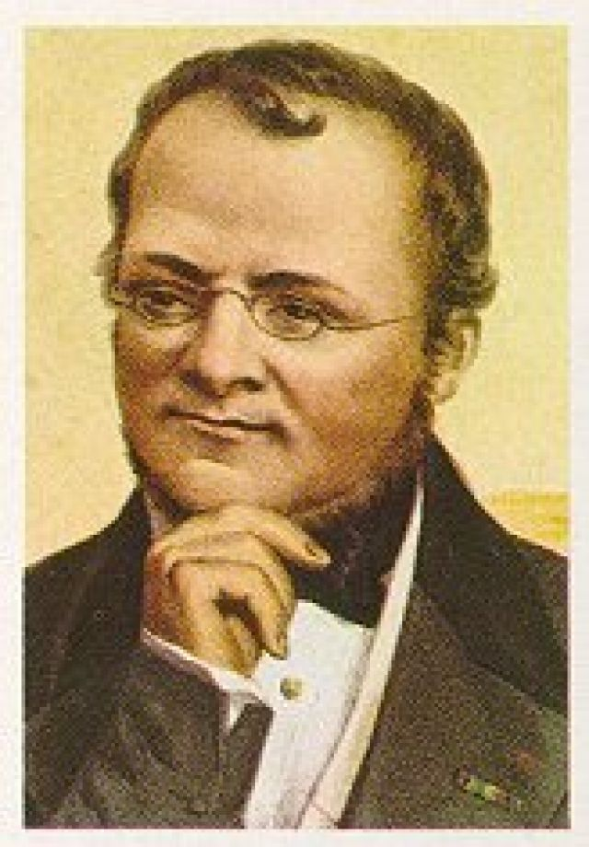

Unification of Italy

1830-1861

Nationalism

Giuseppe Mazzini was considered the “soul” of Italy. On 1830 he was a part of a group whose main interest was to bring together the Italian city-states. He was sent into exile because of his political views. While in exile, he created a secret society named “Young Italy.” Again the main goal was to free Italian lands from control and to unify the Italian peninsula under one common Italian government. With revolutions spreading around Europe, Mazzini returned to Italy to try to spread revolutions there. Although many of the uprisings were unsuccessful, Mazzini organized and spread his revolutionary ideas around the Italian city-states.

# The “Soul” The “Brain” The “Sword”

### At this time, many Italians lived in separate independent city-states or areas under the control by other kingdoms/empires. In 1815 there was not Italy as we know it today. Austria and the pope controlled much of this land. They feared that nationalism was a threat to their power. If Italians broke away, Austria/Pope would lose land and power. Three men engaged in the process of nationalism to unify Italy.

## 1) Why were Mazzini, Cavour and Garibaldi nicknamed the “soul/brain/sword?”

## 2) Explain the steps of Italian Unification

## 3) How did Nationalism help unify Italy?

# Questions

### The Austrian forced the king of Sardinia to give up his power due to fear of revolutions. The new king Victor Emanuel II named Camillo di Cavour as his new prime minister. Cavour would become the “brains” of the operation. His expertise was in foreign affairs. He understood that Austria stood in the way of Italian unification so he gained an alliance with France. When Austria declared war on Sardinia, France had their backs. Defeating the Austrians, Cavour was able to gain Italian lands and future allies. This was a major step in unification.

“You president Lincoln are a true heir of the teaching given us by Christ…It is America, the same country that taught liberty to our forefathers… we are sadly reminded, how this old Europe, which also can boast a great cause of liberty to fight for, had not found the mind or the heart to equal you.”

Letter from Garibaldi to President Abraham Lincoln

Giuseppe Garibaldi was a young revolutionary who joined Mazzini’s “young Italy.” He gained the nickname “the sword” for his actions on the battlefield fighting. He was on the front lines fighting for Italian freedom. When Mazzini’s revolutions failed, Garibaldi went into exile because if he was found he would have faced death. He fought under the king of Sardinia when he returned from exile. He gathered an army of 1000 volunteers to fight in Sicily. They were named the “red shirts” because of their red uniforms. He was able to use nationalism to get Sicilians to join his cause. He then marched north into Italy while Cavour sent an army south. Both armies freed all of the Italian city-states and in 1861 Victor Emanuel II became the ruler of a unified Italy. The only two areas left were Rome and Venice. When Italy helped Prussia defeat Austria they gained control over Venice.