Class/Subject: Philosophy | Lesson 38: “Drilling using Logic”
Objective(s):  SWBAT apply their logical abilities to solve problems. SWBAT draw parallels to the philosophy of pragmatism using the drills as examples. We will break down correct answers as a class to illuminate what proper logic entails. | Unit- “LOGIC”
Philosophical Quotes of the Day:  “Bad reasoning as well as good reasoning is possible; and this fact is the foundation of the practical side of logic.”  -Charles Sanders Peirce | Philosophical Video of the Day:  https://www.youtube.com/watch?v=rog8ou-ZepE- Vanilla Ice’s Ice Ice Baby (Can you find the line about pragmatism?)
Key Points of the Day:

- Pragmatism is a philosophical tradition that began in the United States around 1870. Pragmatism is a rejection of the idea that the function of thought is to describe, represent, or mirror reality. Instead, pragmatists consider thought to be a product of the interaction between organism and environment. Thus, the function of thought is as an instrument or tool for prediction, action, and problem solving. Pragmatists contend that most philosophical topics—such as the nature of knowledge, language, concepts, meaning, belief, and science—are all best viewed in terms of their practical uses and successes.
Journal Entry:  In lieu of a journal entry, I want you to write your graphic organizers and notes, along with your solutions. I get to be a math teacher for a minute and tell you all to, “SHOW YOUR WORK!” | Featured philosopher and supplemental reading:  “PHILOSOPHICAL WRITINGS OF PEIRCE” by: Charles S. Peirce, and Justus Buchler  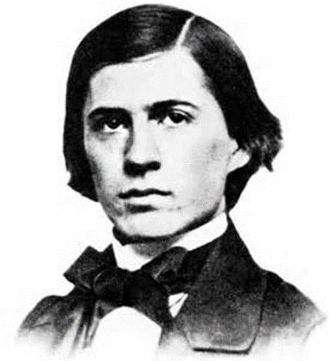  Charles Sanders Peirce was an American philosopher, logician, mathematician, and scientist who is sometimes known as "the father of pragmatism".

