Class/Subject: Philosophy | Lesson 34: “Introduction to Logic/Deductive Reasoning”
Objective(s): SWBAT create a basic schema of what logic is. SWBAT be able to discern logic between epistemology, aesthetics, ethics, and mathematics. SWBAT make real-world parallels to when and where logical thinking is used. SWBAT play a “Quarto” tournament as an example of deductive reasoning. | UNIT: LOGIC
Philosophical Quote of the Day:  “Logic and mathematics are nothing but specialized linguistic structures”. -Jean Piaget | Philosophical Song of the Day: Tool- “Schism”  https://www.youtube.com/watch?v=UhjG47gtMCo
Key Points of the Day:  - Formal logic is more like the sciences than is any other part of philosophy: it aims at a systematic account of a body of "phenomena" on which there is fairly widespread agreement and in order to do so it uses formal methods of representation and formal techniques. Formal logic is formal in that it seeks to give a systematic account of the validity of individual arguments only insofar as they exemplify certain "patterns of argument". Patterns, or forms, of argument are the main object of study. It is this feature of logic that allows us to establish some results in and about logic with the same exactness as one encounters in mathematics. | - Two further considerations are often given as reasons for studying logic:  Logic is "therapeutic": one learns logic in order to become better able to recognize and to construct good arguments (in philosophy or any other discipline).  Formal logic is an indispensable item in the contemporary philosopher's toolkit.  - The goal of establishing logical arguments is to achieve Reductio ad absurdum, or reducing your opponent’s argument to absurdity.  4) Deductive Reasoning is a means of taking all possibilities and using a process to narrow down an outcome to one.
Journal Entry:  “What thinking processes were required in order to be successful in Quarto? What are the differences between inductive and deductive reasoning? Provide examples from real life of when deductive reasoning is used.” | Featured philosopher and supplemental reading: “Reductio Ad Absurdum” by: Ken Vallario  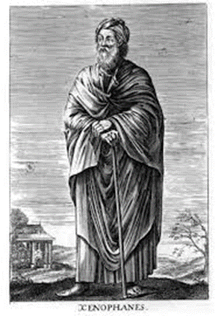  Xenophanes of Colophon was a Greek philosopher, theologian, poet, and social and religious critic. Xenophanes lived a life of travel, having left Ionia at the age of 25 and continuing to travel throughout the Greek world for another 67 years.

