Class/Subject: Philosophy | Lesson 6- “What is Wisdom?”
Objective(s):  SWBAT to evaluate what constitutes wisdom and critique the work of philosophy, in this case the writings of Will Durant. | Unit: Epistemology
Philosophical Quote of the Day:  “Science gives us knowledge, but only philosophy can give us wisdom”- Will Durant | Philosophical Song of the Day:  “Live Like You Were Dying”- Tim McGraw  https://www.youtube.com/watch?v=_9TShlMkQnc
Key Points of the Day:

One of the root words of philosophy is, “soph”, which is Greek for, “wisdom”. Using philosophy as a means of acquiring wisdom and creating a personal definition of the concept is an essential element of the discipline.

How does one gain wisdom? How does one know who and what is wise? How does the idea of wisdom apply on a personal level? Durant felt it was being able to grasp the broader, full perspective of existence.
Journal Entry:  “How would you define, “wisdom” and what steps can be taken to increase it during the course of a lifetime? Do you consider yourself wise, or not? Explain.” | Supplemental Reading: “The Story of Philosophy” –Will Durant  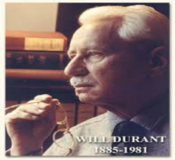  William James Durant was an American writer, historian, and philosopher. He is best known for The Story of Civilization, 11 volumes written in collaboration with his wife Ariel Durant and published between 1935 and 1975.

