Class/Subject: Philosophy | Lesson 1- “Introduction to the Study of Philosophy”
Objective(s):  SWBAT learn what the structure and expectations of the class are. SWBAT also be able to state what the five components of philosophy are. | Unit: “KNOW THYSELF”
Philosophical Quote of the Day:  “The unexamined life is not worth living” -Socrates | Philosophical Video of the Day:  “Self Awareness”, by KRS-ONE- https://www.youtube.com/watch?v=dB_KaKeeX44
Key Points of the Day:  - WELCOME!!!!! GLAD YOU’RE IN PHILOSOPHY CLASS WITH ME.  - You’ll need a notebook to keep a journal.  - Please bookmark my class page- SALCICCIOLI MOODLE  - Class Twitter is @CVHSPhilosophy  - The Ancient Greeks felt the foundation of a well-lived human life entailed, “knowing thyself”. | 6. Philosophy means, “love of wisdom” and is in five parts:  - Epistemology  - Aesthetics  - Ethics  - Logic  - Metaphysics
Journal Entry:  “What are the five components of philosophy and what are examples of how we think from each of the five? What are your initial thoughts about philosophy as we start this class?” | Supplemental Reading and Philosopher: Ayn Rand, Philosophy: Who Needs It  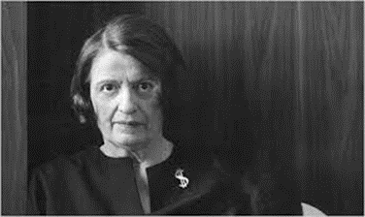  Ayn Rand was a Russian-American novelist, philosopher, playwright, and screenwriter. She is known for her two best-selling novels, The Fountainhead and Atlas Shrugged, and for developing a philosophical system she called Objectivism.

