**Physics B Review Sheet – Optics Name ____ANSWERS_________ Hour__ Date _________**

1) Match two of these terms with each of the diagrams below:

Converging Mirror      Convex Mirror Converging Lens Diverging Mirror  
Diverging Lens   Concave Lens       Convex Lens Concave Mirror

______Convex Lens__ _____Concave Lens__ __ _Concave Mirror___ __Convex Mirror__

_Converging Lens____ ___Diverging Lens___ ____ __Converging Mirror_ ____Diverging Mirror_

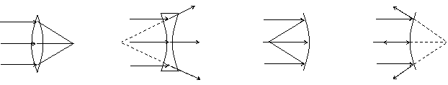

2) Define focal point for a convex lens.

The point at which light rays parallel to the principal axis will converge after being refracted by the lens.

3) Describe how tell whether an image is real or virtual.

If the light rays actually converge at a point, then image is real. (can be projected on screen)

If the rays seem to have come from one point, but never actually crossed, then the image is virtual.

4) Describe why plane mirrors can’t form a real image.

Plane mirrors are not able to cause light rays to converge. If light rays from an object are diverging when they arrive at the mirror, they will still be diverging when they leave the mirror.

5) Label the two different types of telescopes, and name the indicated parts.

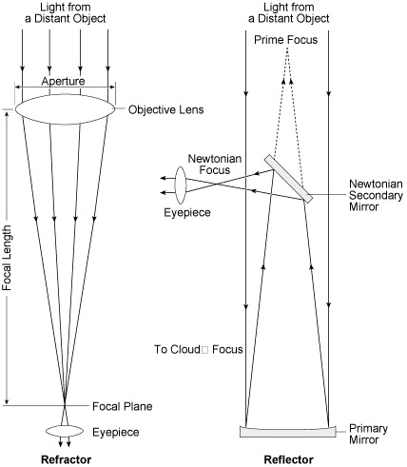

Objective lens

Eyepiece lens

Secondary Mirror

Primary Mirror

___Refracting__ telescope

_____Reflecting____ telescope

6) What are two benefits of reflecting telescopes compared to refracting telescopes?

Reflecting telescopes can be made much larger, because it is easier to make a large mirror than a large lens.

Reflecting telescopes don’t have chromatic aberration, because reflection doesn’t cause dispersion.

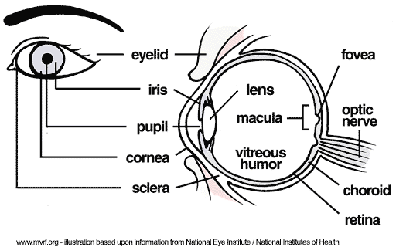7) Name the parts of the human eye which perform the following functions:

|  |  |
| --- | --- |
| Function | Part of Eye |
| Control amount of light entering | Iris |
| Focus the light | Lens (and to a smaller degree, the cornea) |
| Detect light | Retina |
| Hold all the pieces together | Sclera (the white of the eye) |
| Explain: How do you change from focusing on a distant object to focusing on a nearby object? | Ciliary muscles in your eye contract, which squeezes the lens into a rounder shape, with a shorter focal length. |

8) Describe the problem with the eye to the right. Describe what type of vision correction would help, and how.

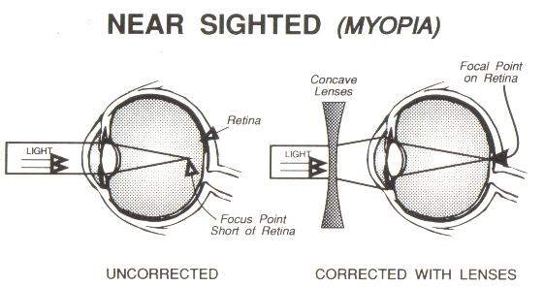

The eye to the right is nearsighted (myopic). The rays focus before they get to the retina, and then spread out again before they reach the retina, which results in a blurry image.

To help the rays spread out more (diverge) before they reach the lens, a concave lens can be placed in front of the eye or on the cornea.9) Explain this diagram. Refer to the letters and try to use precise optics terms.

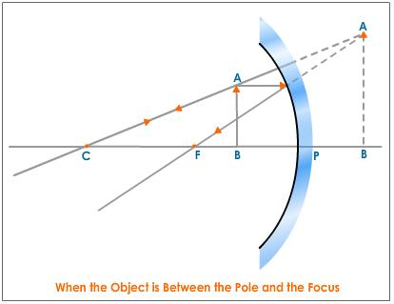

A’

B’

* Concave mirror
* AB is Object
* A’B’ is Virtual image, upright, magnified, behind mirror
* Image is virtual because rays don’t cross, but seem to have come from that point
* C is center, F is focal point

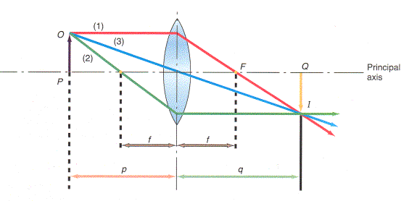10) Explain this diagram as precisely as you can. Describe the image using specific terminology.

* Convex lens
* f is focal length
* Image is Real, slightly magnified, inverted
* Magnified because q (image distance) is slightly larger than p (object distance)
* 1) Principal Ray
* 2) Focal Ray
* 3) Central Ray (not bent much)

11)

a) Use Snell’s Law to calculate the index of refraction of a piece of plastic if a laser beam which is 54.0 degrees from the normal travels from air into the plastic, and ends up 38.6 degrees from the normal inside the plastic.

Given: n1=1.0003 (air, basically a vacuum) n2=? Ans: n2 = 1.30 (to three significant digits)

θ1=54.0° θ2=38.6°

b) Sketch a diagram and calculate the angle of incidence for a ray of light which travels from water (n=1.33) into a diamond, and ends up traveling at an angle of 62 degrees from the surface of the diamond (n=2.52).

12) On a separate page, calculate the missing values for each of the following lenses:

a) Image Distance = 43.1 cm Object distance = 82.5 cm f=?

b) f=21.0 cm Object distance = 31.5 cm Image distance = ? Magnification = ?

c) f=11.8 cm Object distance = 7.20 cm Image distance =? Magnification = ?

Explain the odd results from c by sketching a diagram.

13) Calculate the critical angle for a laser beam which traveling through a glass fiber in a water tank. The index of refraction of the glass is 1.71, and the index of refraction of water is 1.33. Remember that the critical angle (of incidence) is the angle which would result in a ray being refracted at 90° from the normal, which is along the boundary between the media.

Sketch a diagram of the situation and rays described.