Child Labor in America, 1908-1912: The Photographs of Lewis W. Hine
During the early years of the twentieth century photographer Lewis Hine traveled the
country documenting the child in the workplace through photographs and vivid written descriptions. Rapid industrialization and a lack of regulation led some employers to look to the nation's youth for cheap labor. Exploitation was rampant. Hine served as an investigator for the National Child Labor Committee, established to "combat the danger in which childhood is placed by greed and rapacity." He used any pretext to gain entrance to a factory often secretly interviewing the children, concealing his note taking by keeping his hands in his pockets. When barred from entrance, Hine waited outside the factory gate taking his pictures as the children left work. His photos were widely distributed, their impact greater than any printed word. The impression they made contributed significantly to the reform of child labor.

As early as the 1830s, many U.S. states had enacted laws restricting or prohibiting the employment of young children in industrial settings. However, in rural communities where child labor on the farm was common, employment of children in mills and factories did not arouse much concern. Another problem for children was the popular opinion that gainful employment of children of the "lower orders" actually benefited poor families and the community at large.

Entire families were hired, the men for heavy labor and the women and children for lighter work. Work days typically ran from dawn to sunset, with longer hours in winter, resulting in a 68-72 hour workweek. Many families also lived in company owned houses in company owned villages and were often paid with overpriced goods from the company store. Thus they lived a life entirely dominated by their employers.

By the late 1800s, states and territories had passed over 1,600 laws regulating work conditions and limiting or forbidding child labor. In many cases the laws did not apply to immigrants, thus they were often exploited and wound up living in slums working long hours for little pay.

Throughout America, local child labor laws were often ignored. On a national level, progress to protect children stalled as the U.S. Supreme Court ruled several times that child labor laws under question were unconstitutional. A subsequent attempt to pass an amendment to the U.S. Constitution failed.

In 1904, the National Child Labor Committee was organized by socially concerned citizens and politicians, and was chartered by Congress in 1907. From 1908 to 1912, photographer Hine documented numerous gross violations of laws protecting young children. At many of the locations he visited, youngsters were quickly rushed out of his sight. He was also told youngsters in the mill or factory had just stopped by for a visit or were helping their mothers.

Attempts at child labor reform continued, aided by the widespread publicity from Hine's photographs. As a result, many states passed stricter laws banning the employment of underage children. In 1938, Congress passed the Fair Labor Standards Act, better known as the Federal Wage and Hour Law. The Act was declared constitutional in 1941 by the U.S. Supreme Court.

The Act set a work week of 40 hours, with a minimum wage of 40 cents per hour. It prohibited child labor under age 16 while allowing minors 16 and over to work in non-hazardous occupations. The Act set 18 as the minimum age for work in industries classified as hazardous. No minimum age was set for non-hazardous agricultural employment after school hours and during vacations. Children aged 14 and 15 could be employed in non-manufacturing, non-mining, and non-hazardous occupations outside of school hours and during vacations for limited hours.
Clothing Mills

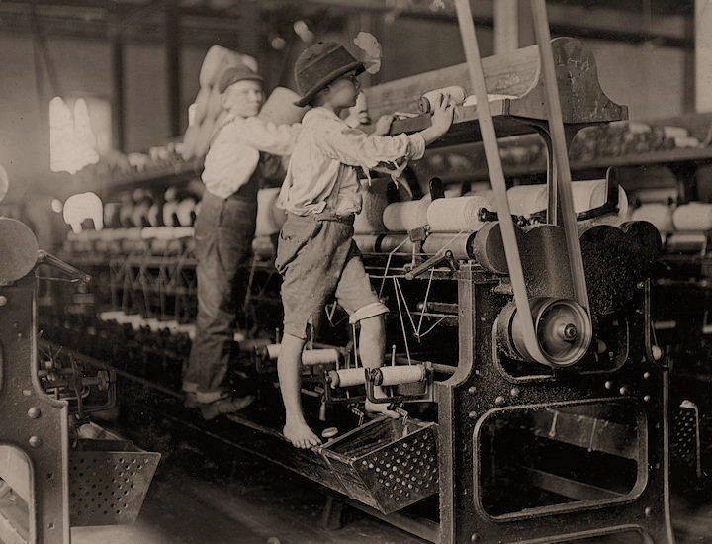

The Mill: Some boys and girls were so small they had to climb up on to the spinning frame to mend broken threads and to put back the empty bobbins. Bibb Mill No. 1. Macon, Georgia.

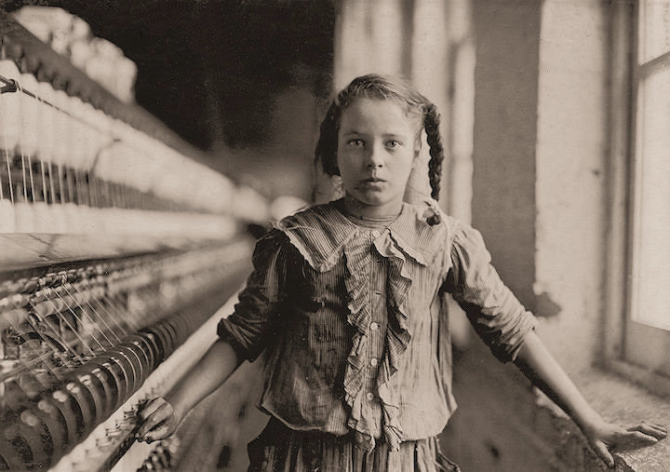

The Mill: One of the spinners in Whitnel Cotton Mill. She was 51 inches high. Has been in the mill one year. Sometimes works at night. Runs 4 sides - 48 cents a day. When asked how old she was, she hesitated, then said, "I don't remember," then added confidentially, "I'm not old enough to work, but do just the same." Out of 50 employees, there were ten children about her size. Whitnel, North Carolina.

Miners

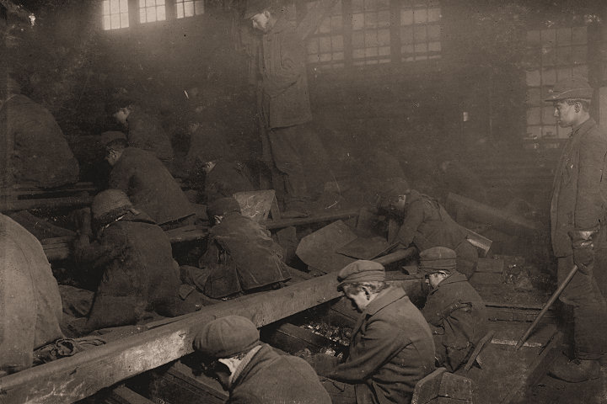

Miners: View of the Ewen Breaker of the Pennsylvania Coal Co. The dust was so dense at times as to obscure the view. This dust penetrated the utmost recesses of the boys' lungs. A kind of slave-driver sometimes stands over the boys, prodding or kicking them into obedience. South Pittston, Pennsylvania.

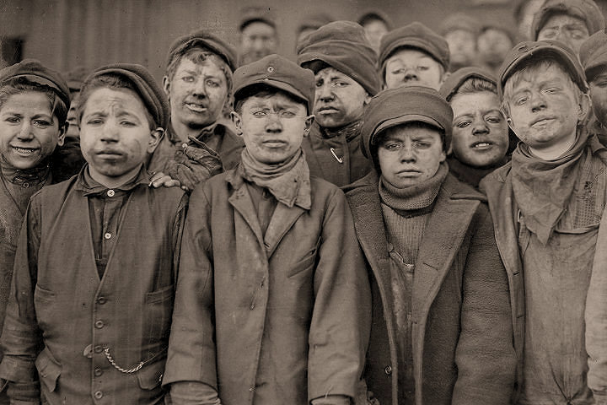

Miners: Breaker boys. Smallest is Angelo Ross. Pittston, Pennsylvania.

Factories

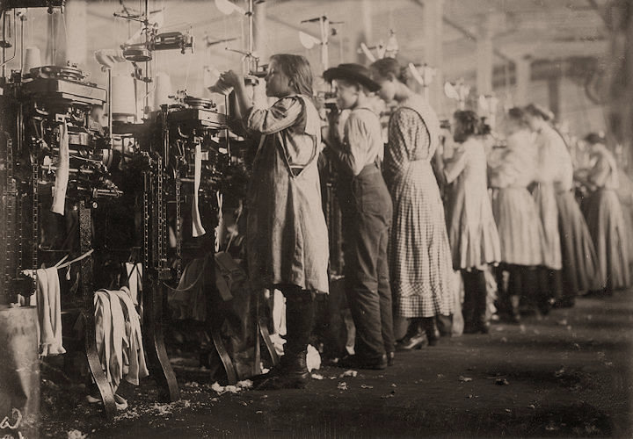

The Factory: Some of the young knitters in London Hosiery Mills. London, Tennessee.

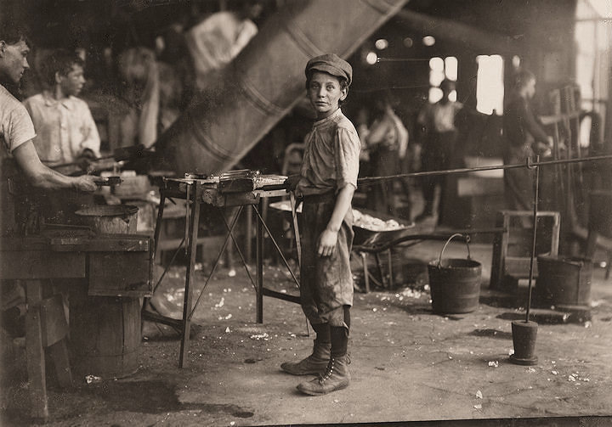

The Factory: Rob Kidd, one of the young workers in a glass factory. Alexandria, Virginia.

Seafood Workers

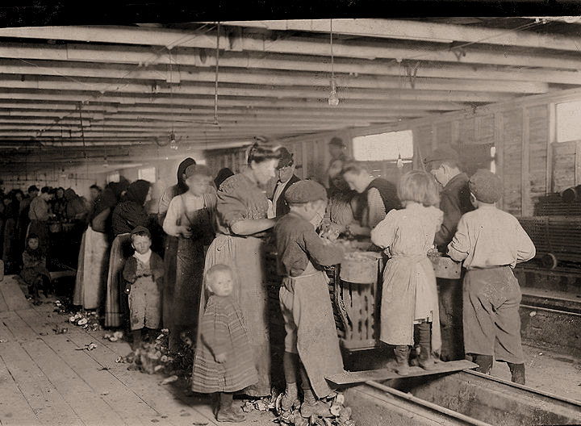

Seafood Workers: Oyster shuckers working in a canning factory. All but the very smallest babies work. Began work at 3:30 a.m. and expected to work until 5 p.m. The little girl in the center was working. Her mother said she is "a real help to me." Dunbar, Louisiana.

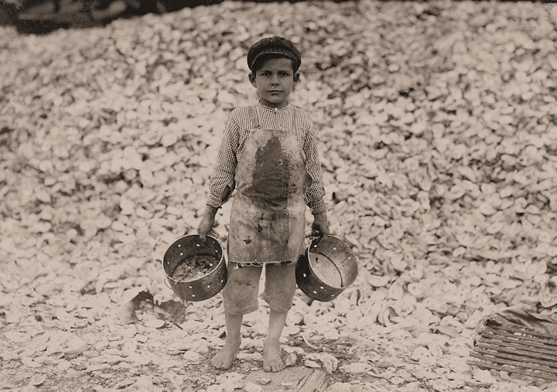

Seafood Workers: Manuel the young shrimp picker, age 5, and a mountain of child labor oyster shells behind him. He worked last year. Understands not a word of English. Biloxi, Mississippi.

