Causes of World War One – Student Handout
Although it was the assassination of the Austrian archduke, Franz Ferdinand that led to the outbreak of World War I in August 1914, the actual causes of the war were more complicated and not confined to a single cause.

Alliances
An alliance is an agreement made between two or more countries to give each other help if it is needed. When an alliance is signed, those countries become known as Allies. A number of alliances had been signed by countries between the years 1879 and 1914. These were important because they meant that some countries had no option but to declare war if one of their allies declared war first.

Imperialism  Imperialism is when a country takes over new lands or countries and makes them subject to their rule. By 1900 the British Empire extended over five continents and France had control of large areas of Africa. The amount of lands 'owned' by Britain and France increased the rivalry with Germany who had entered the scramble to acquire colonies late and only had small areas of Africa. |  | 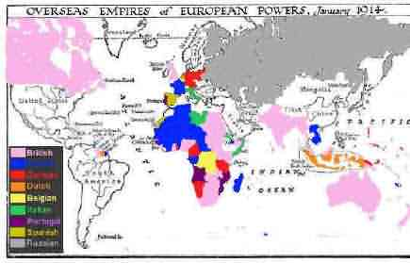Pink = British Blue = French  Red = German
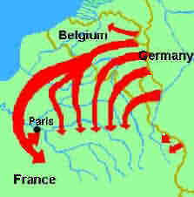 | Militarism  Militarism means that the army and military forces are given a high profile by the government. The growing European divide had led to an arms race between the main countries. The armies of both France and Germany had more than doubled between 1870 and 1914 and there was fierce competition between Britain and Germany for mastery of the seas. The British had introduced the 'Dreadnought', an effective battleship, in 1906. The Germans soon followed suit introducing their own battleships. The German, Von Schlieffen also drew up a plan of action that involved attacking France through Belgium if Russia made an attack on Germany.

Nationalism
Nationalism means being a strong supporter of the rights and interests of one's country. During this period, nationalist feeling ran high as the countries of Europe sought to restructure themselves. The Congress of Vienna, held after the Napoleonic wars, left both Germany and Italy as divided states. Nationalism inspired the re-unification of Italy in 1861 and Germany in 1871. For its part, France was angry because the settlement at the end of the Franco-Prussian war had given Alsace-Lorraine to Germany. Large areas of both Austria-Hungary and Serbia were home to differing nationalist groups, all of whom wanted freedom from the states in which they lived.

Crises
The Moroccan Crisis - In 1904 Morocco had been given to France by Britain, but the Moroccans wanted independence and was supported by Germany. War was avoided, but in 1911, the Germans were again protesting against French possession of Morocco. Britain supported France and Germany was persuaded to back down for part of French Congo.

The Bosnian Crisis - In 1908, Austria-Hungary took over Bosnia. This angered Serbians who felt the province should be theirs. Serbia threatened Austria-Hungary with war, Russia, allied to Serbia, mobilized its forces. Germany, allied to Austria-Hungary mobilized its forces and prepared to threaten Russia. War was avoided when Russia backed down. In 1911 and 1912 there was war in the Balkans when the Balkan states drove Turkey out of the area. The states then fought each other over which area should belong to which state. Austria-Hungary intervened and forced Serbia to give up land. Tension between Serbia and Austria-Hungary was high.

Alliances
An alliance is an agreement made between two or more countries to give each other help if it is needed. When an alliance is signed, those countries become known as Allies.
A number of alliances had been signed by countries between the years 1879 and 1914. These were important because they meant that some countries had no option but to declare war if one of their allies declared war first.
1879  The Dual Alliance    Germany and Austria-Hungary made an alliance to protect themselves from Russia | 1881  Austro-Serbian Alliance  Austria-Hungary made an alliance with Serbia to stop Russia gaining control of Serbia | 1882  The Triple Alliance  Germany and Austria- Hungary made an alliance with Italy to stop Italy from taking sides with Russia
1914  Triple Entente (no separate peace)  Britain, Russia and France agreed not to sign for peace separately. |  | 1894  Franco-Russian Alliance  Russia formed an alliance with France to protect herself against Germany and Austria-Hungary
1907  Triple Entente  This was made between Russia, France and Britain to counter the increasing threat from Germany. | 1907  Anglo-Russian Entente  This was an agreement between Britain and Russia | 1904  Entente Cordiale  This was an agreement, but not a formal alliance, between France and Britain.

Read the table above clockwise from the top left picture.

World War One Causes. History on the Net. 7 October 2009 <http://www.historyonthenet.com/WW1/causes.htm#Alliances>.

Imperialism

Imperialism is when a country takes over new lands or countries and makes them subject to its rule. By 1900 the British Empire extended over five continents and France had control of large areas of Africa. With the rise of industrialism countries needed new markets. The amount of lands 'owned' by Britain and France increased the rivalry with Germany who had entered the scramble to acquire colonies late and only had small areas of Africa. Note the contrast in the map below.

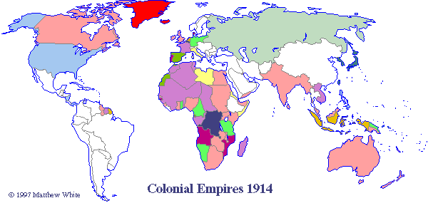

The map above links countries and their colonies through the use of color. For example, the United Kingdom is colored in pink and corresponds with its colonies in present-day Canada, Australia, South Africa, India, Sudan, Egypt among others.

Price, Richard, History 219P. University of Maryland. Department of History. 7 October 2009 <http://www.history.umd.edu/Faculty/RPrice/Coursedirectory/219/maps.html#Empires1914>.

Militarism

Militarism means that the army and military forces are given a high profile by the government. Countries build up their armed forces in the name of security, thereby intimidating other nations. The growing European divide had led to an arms race between the main countries. The armies of both France and Germany had more than doubled between 1870 and 1914 and there was fierce competition between Britain and Germany for mastery of the seas. The British had introduced the 'Dreadnought', an effective battleship, in 1906. The Germans soon followed suit introducing their own battleships. The German, Von Schlieffen, also drew up a plan of action that involved attacking France through Belgium if Russia made an attack on Germany. The map below shows how the plan was to work.

Nationalism
Nationalism means being a strong supporter of the rights and interests of one's country. The Congress of Vienna, held after Napoleon's exile to Elba, aimed to sort out problems in Europe. Delegates from Britain, Austria, Prussia and Russia (the winning allies) decided upon a new Europe that left both Germany and Italy as divided states. Strong nationalist elements led to the re-unification of Italy in 1861 and Germany in 1871. The settlement at the end of the Franco-Prussian war left France angry at the loss of Alsace-Lorraine to Germany and keen to regain lost territory. Large areas of both Austria-Hungary and Serbia were home to differing nationalist groups, all of whom wanted freedom from the states in which they lived.

http://www.historyonthenet.com/WW1/causes.htm#Alliances

