Chapter 19 Review Sheet – Optics Name KEY - ANSWERS AT END Block____
1) Match two of these terms with each of the diagrams below:
Converging Mirror Convex Mirror Converging Lens Diverging Mirror
Diverging Lens Concave Lens Convex Lens Concave Mirror

_____________________ _____________________ _____________________ _____________________
_____________________ _____________________ _____________________ _____________________
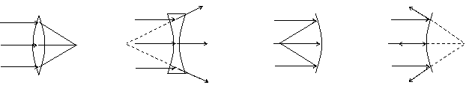
2) Define focal point for a convex lens.

3) Describe how tell whether an image is real or virtual.

4) Describe why plane mirrors can not form a real image.

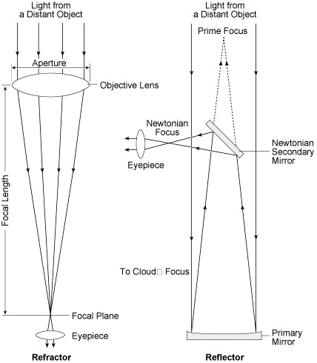
5) Label the two different types of telescopes, and name the indicated parts.
________________________ telescope
________________________ telescope

6) What are two benefits of reflecting telescopes compared to refracting telescopes?

7) Name the parts of a camera and the human eye which perform the following functions:
Function | Camera | Eye
Control amount of light entering
Focus the light
Detect light
Hold all the pieces together
*Bonus: How do you change from focusing on a near object to focusing on a distant object?
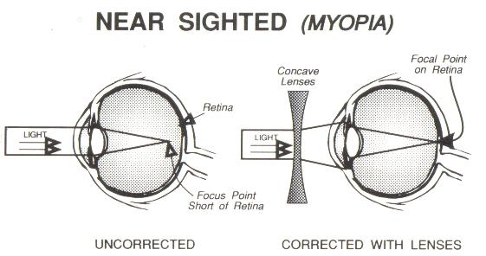
8) Describe the problem with the eye to the right. Describe what type of vision correction would help, and how.

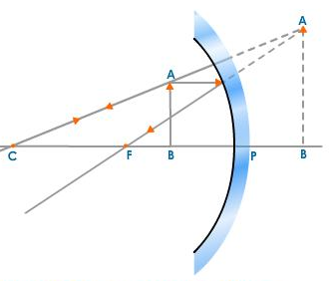
9) Explain this diagram. Refer to the letters and try to use precise optics terms.
A’
B’

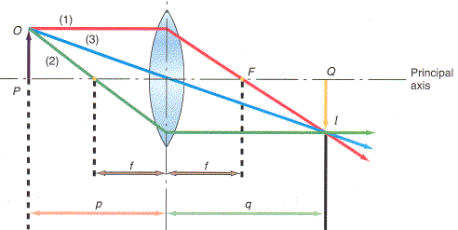
10) Explain the labeled points and rays in this diagram. Describe the image.

Chapter 19 Review Sheet – Optics Name ___ KEY __________ Block____
1) Match two of these terms with each of the diagrams below:
Converging Mirror Convex Mirror Converging Lens Diverging Mirror
Diverging Lens Concave Lens Convex Lens Concave Mirror

__ Convex Lens ___ ____ Concave Lens __ __ Concave Mirror ___ __ Convex Mirror ___
_ Converging Lens_ __ Diverging Lens ____ __ Converging Mirror __ __ Diverging Mirror ___
2) Define focal point for a convex lens.
The focal point is the point at which light rays parallel to the axis will converge and meet, after they have passed through the lens.

3) Describe how tell whether an image is real or virtual.
An image is real if the light rays really cross, and if it can be shown on a screen or paper. (Real images which are formed by one mirror or one lens are always inverted.)

4) Describe why plane mirrors can not form a real image.
To form a real image, the light rays must cross. A plane mirror does not cause light rays to converge. Light rays that are diverging and then hit a plane mirror will go in the other direction, but they will still be diverging, and not cross to form a real image.

5) Label the two different types of telescopes, and name the indicated parts.
objective lens
eyepiece lens
secondary mirror
primary mirror
__Refracting__ telescope
____ Reflecting ___ telescope

6) What are two benefits of reflecting telescopes compared to refracting telescopes?

7) Name the parts of a camera and the human eye which perform the following functions:
Function | Camera | Eye
Control amount of light entering | Aperture / Diaphragm | Pupil
Focus the light | Lens (or set of lenses) | Lens
Detect light | Film or CCD (for modern digital cameras) | Retina (rods and cells)
Hold all the pieces together | Camera body | Sclera
*Bonus: How do you change from focusing on a near object to focusing on a distant object? | Adjust the position of the lenses; change the image length | Adjust the focal length of the lens by squeezing the lens with muscles
8) Describe the problem with the eye to the right. Describe what type of vision correction would help, and how.
The eye is nearsighted. The light rays are crossing before they hit the retina, and have spread out by the time they hit the retina, making a fuzzy image.
The person should use a concave lens to make the rays diverge before they hit the eye, fixing the problem.
9) Explain this diagram. Refer to the letters and try to use precise optics terms.
A’
B’
F is the focal point of the concave mirror.
AB is the object.
A’B’ is the virtual image. It is magnified, and upright.
(The object is magnified because it is inside the focal length. Outside the focal length, it would make an upside down real image.)
C is the center of the mirror.
10) Explain the labeled points and rays in this diagram. Describe the image.
F: Focal point
f: focal length
1: Principal Ray; parallel to axis, bends at lens and goes through far focal point
2: Focal Ray; goes through focal point, bends at lens, then exits parallel to axis.
3: Central Ray; goes through center of lens, does not bend significantly
p: object distance
q: image distance
The image is real, inverted, and slightly larger than the original. (The image distance is slightly larger than the object distance.)

