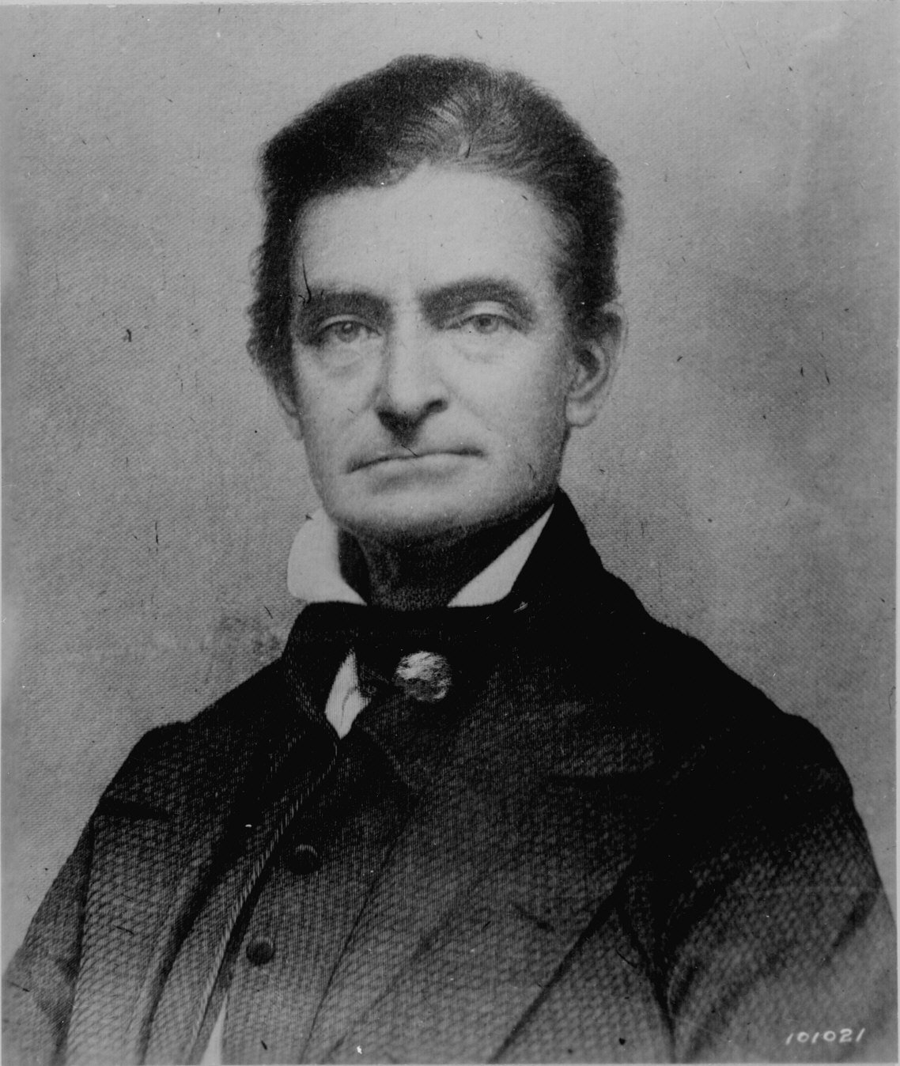
Journal 16
Portrait of John Brown

