Restriction Enzymes and Gel Electrophoresis

Once the DNA is copied by PCR, scientists use restriction enzymes to break the DNA into smaller pieces or fragments.
These fragments can be put into a gel. Running electricity through the gel causes the fragments to separate out according to size. Gel electrophoresis gives you the ability to visualize the fragment patterns for comparison. Scientists look for restriction fragment length polymorphisms (RFLP’s) to solve the case.

Materials:
DNA UV light box
Gel box with electrical cords Dye
Power source Pipette
Agarose gel
Gel tray
Gel comb to make wells
TAE buffer solution

Procedure:
After making the gel, let it cool, put DNA into the wells, and put the gel tray in the gel box. Add the buffer, hook up the power and let ‘er rip! The DNA is negatively charged so it will move through the gel towards the positive electrode. When it is done you can stain the DNA with dye and look at it on a UV light box. You will be able to see the DNA fragments.
1 piece of DNA is cut into different fragments by
different enzymes

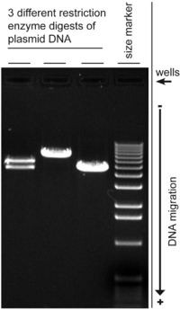
Put DNA in wells. Each well holds one sample
DNA is pulled to + end. Smaller fragments move faster
http://en.wikipedia.org/wiki/Agarose_gel_electrophoresis

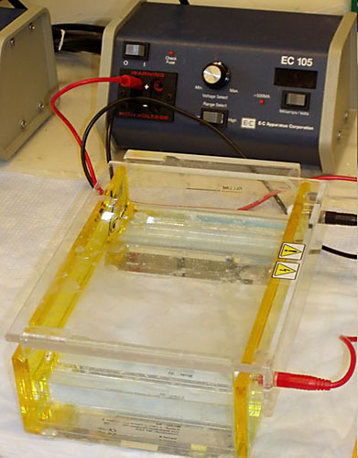
Can you identify all these things?

http://www.sciencebuddies.org/science-fair-projects/project_ideas/BioChem_p028.shtml

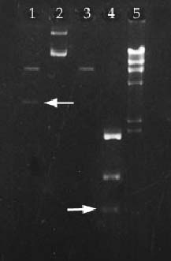
RFLP Analysis – check out these fragments. Are any of these from the same people? Is there a match?
http://students.ncwc.edu/bio401/2004/team_b/what_is_gel_electrophoresis.htm

Besides solving crime, what are some other reasons serologists would use these methods?

