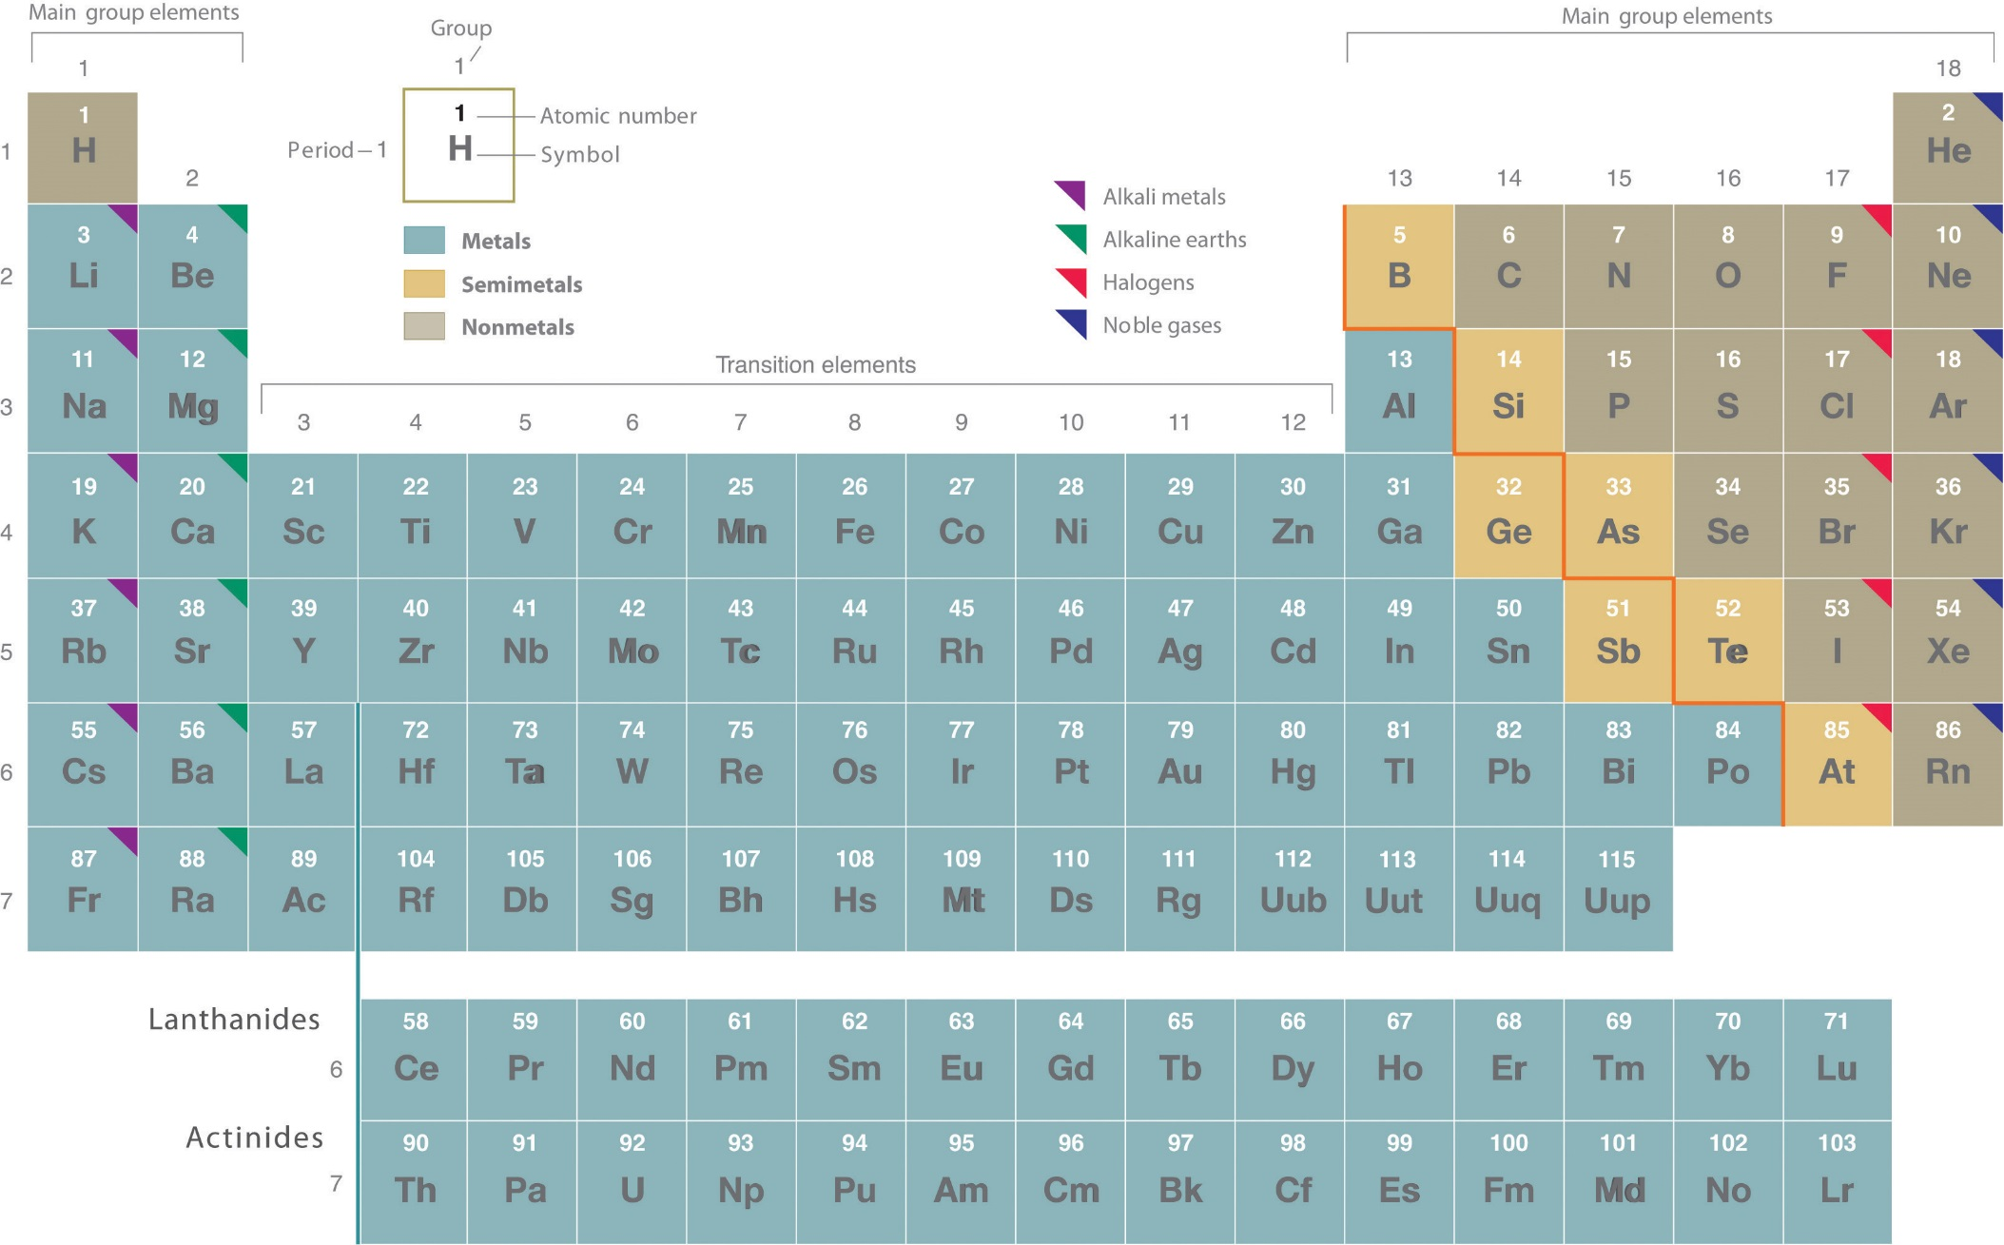
https://www.google.com/url?sa=i&source=images&cd=&cad=rja&uact=8&ved=2ahUKEwjCgIPuwMDeAhUE9YMKHZJxCe8QjRx6BAgBEAU&url=https%3A%2F%2Fchem.libretexts.org%2FTextbook_Maps%2FGeneral_Chemistry%2FMap%253A_Chemistry_-_The_Central_Science_(Brown_et_al.)%2F02._Atoms%252C_Molecules%252C_and_Ions%2F2.5%253A_The_Periodic_Table&psig=AOvVaw3wbtdQpJnY-CTfLnMI7uLx&ust=1541619105852801

