Doolittle Raid and the Battle of Midway
Some things you do for show. On April 18, 1942, sixteen B25 bombers, with 80 volunteers commanded by Lieutenant Colonel James Doolittle, took off from the aircraft carrier Hornet. Their mission was to drop the first bombs on Tokyo, Nagoya and Yokohama. All reached their targets successfully, with little Japanese response. Then, low on fuel, fifteen of the planes crashed or were abandoned in China. (The Japanese would eventually execute 250,000 Chinese for helping the American fliers escape.) A sixteenth plane landed near Vladivostok. Two of the Doolittle raiders came down in enemy territory and three crewmen were executed. But 71 men eventually came home.
The raid caused minor damage, but the psychological effect, on both the Americans and the Japanese, was incalculable. Still recovering militarily and emotionally from Pearl Harbor, America had, through a bold stroke by real heroes, brought the war home to Japan. Film of the raid was widely distributed; 30 Seconds Over Tokyo (1943), was a bestseller.
Having bragged that their islands were impregnable, the Japanese High Command felt humiliated. Admiral Yamamoto quickly developed plans for a major naval battle that he thought would secure an ultimate Japanese victory in the war. After considerable debate, he chose to attack Midway Island, 1000 miles from Honolulu. Some Japanese mistakenly believed the Doolittle Raid had been launched from Midway. Also, Midway under Japanese control would be an ideal spot to harass the Americans, especially in Hawaii.
As at Pearl Harbor, the enemy was relying on surprise, unaware that the Japanese code had been broken. "AF" was code for the target designation, but American intelligence didn’t know which possible target was AF. By issuing a false report about a Midway fresh water shortage—immediately sent out by the Japanese as a water shortage at AF—Admiral Nimitz knew Yamamoto's intentions, and began assembling his forces.
Under Yamamoto's personal command, the Japanese sent an armada of more than 100 warships towards Midway. The four-day battle began June 4. Just when it seemed the Japanese might win, U.S. dive-bombers attacked Japanese aircraft carriers while their decks were crowded with refueling planes. During those "fatal five minutes," three and eventually four Japanese carriers were sunk.
U.S. forces didn't confront another major Japanese fleet until the end of 1944. But by then, as a result of the battle of attrition, the Japanese had been effectively defeated.
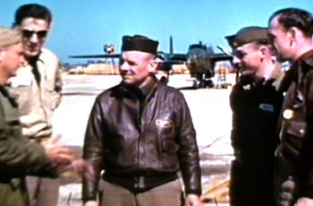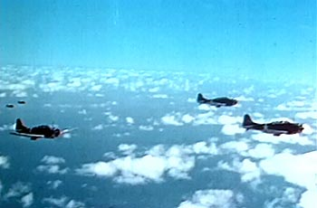
Lieutenant General James Doolittle U.S. Fighter Planes Over The Skies At Midway

