Class/Subject: Philosophy | Lesson 49: “Death”
Objective(s):  SWBAT reflect upon their own notions of death and explore its significance on an individual’s life philosophy. | Unit- “METAPHYSICS”
Philosophical Quote of the Day:  “For life and death are one, even as the river and the sea are one”. - Khalil Gibran | Philosophical Song of the Day:  “Magic and Loss (The Summation)” -Lou Reed  https://www.youtube.com/watch?v=VzQtRRMGRr0 (51:55)
Key Points of the Day:  - Answering questions regarding death is a cultural universal.  - Western philosophers and Eastern philosophers differ greatly in how they view death. | - Death is at the root of many religious and philosophical traditions.
Journal Entry:  “What are your thoughts regarding death? Is focusing on death life-affirming, or life-negating? Explain your rationale. Write this in addition to your obituary. | Featured philosopher and supplemental Reading:  “Being and Time” by: Martin Heidegger  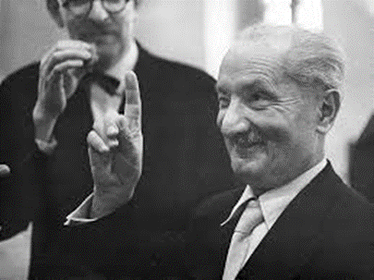  Martin Heidegger was a German philosopher and a seminal thinker in the Continental tradition and philosophical hermeneutics. He is "widely acknowledged to be one of the most original and important philosophers of the 20th century". Heidegger is best known for his contributions to phenomenology and existentialism.

