"WHAT IS A MAN IN REVOLT? A MAN WHO SAYS NO. BUT HIS REFUSAL IS NOT A RENUNCIATION. HE IS A MAN WHO SAYS YES, BEGINNING WITH HIS VERY FIRST MOVE"- ALBERT CAMUS
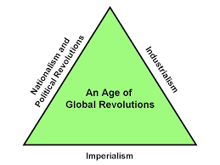

Day 103: Introduction to Revolutions Using Historian's Reasoning Devices (HRD)
Forces of History: What are some examples from today and/or history?
1. Political movements
2. Social and Cultural movements
3. Foreign Affairs
4. Science/Technology/Innovation
5. Economic Changes
6. Intellectual movements
Significance Matrix: Use your own life to illustrate these points
1. Change over time
2. Continuity over time
3. Signals
4. Turning Point
5. Causes
6. Effects
Historical Variables Matrix: Revisit the American Revolution to look at these
1. Context of the times
2. Power
3. Tensions
4. Conflict
5. Consensus
6. Tolerance/Intolerance

Divide up and explore the basic story of how these countries came to be:
- America- page 557
- Haiti- page 646
- Mexico- page 647
- South America- page 648
- Germany- page 693
- Italy- page 700
WHAT COMMON THEMES DID THEY HAVE?

