The Battle of the Bulge
The Battle of the Bulge was the largest battle the U.S. Army ever fought, and the largest it ever came close to losing; a battle so ferocious, and in such horrendous conditions, that very little film, either black and white or color, exists of the conflict.
Hitler's masterstroke was to attack when Allied command thought that... "the enemy is... fighting a defensive campaign; he cannot stage major offensive operations." That intelligence report was submitted December 16, 1944, the same day secretly advanced German panzer divisions broke through weak Allied lines along a 70 mile front in Belgium's Ardennes forest. One U.S. Division was quickly destroyed; others were in deadly peril. Panzers and Wehrmacht troops rapidly drove west through the Ardennes, creating "The Bulge" in the German lines. In this last effort at victory, Hitler hoped to reach Antwerp and sue for peace.
The Nazis were helped by bad weather, which kept Allied planes grounded and forced troops to fight in sub-zero temperatures. (A GI says in The Perilous Fight, "The bolt would freeze on our machine guns. We remedied that by urinating on them just before we fired them...") With small victories at first, the Allies fought back, showing a determination exemplified by Brigadier General Anthony McAuliffe's famous response when asked by the Germans to surrender Bastogne: "Nuts." On Christmas Eve the skies finally cleared and 10,000 Allied airplanes went on the attack. By January 3 the Germans were on the defensive; by month's end Hitler's last opportunity to achieve anything but defeat was lost.
110,000 Germans were killed, wounded or captured-many the teenagers and old men Hitler had used to reinforce his dwindling troops. 80,000 Americans were killed, wounded or captured-a statistic unequaled in American history. Many of those soldiers were fresh from high school; some of the others were African Americans, allowed to fight on the front lines for the first time because of manpower shortages. And one American loss was intentional. So many green soldiers ran away that Command felt someone had to pay the ultimate price for desertion, as a lesson to the others. The man chosen was Private Eddie Slovik-the only American soldier ever executed for desertion. In the 1974 television film of his story, Slovik was played by Perilous Fight narrator Martin Sheen.
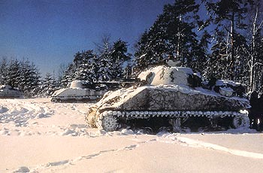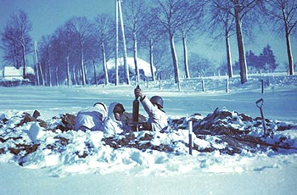
M-4 Sherman Tanks Soldiers firing a motor

