Why is the Sky Blue?
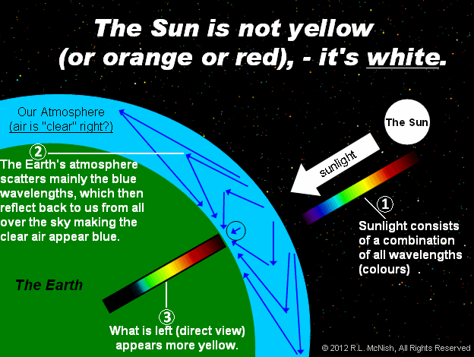
The sun sends out all visible colors. It is white, not yellow. If the sun were yellow, the moon would look yellow.
Light scatters off of the nitrogen molecules which make up 78% of our atmosphere.
Short wavelengths such as violet and blue scatter much more than long wavelengths such as red.
This means that blue and violet light come at us from every portion of the sky, but red, yellow, and green arrive from the sun with little scattering. Our eyes and brain average out the red, yellow, and green and perceive the sun as yellow.
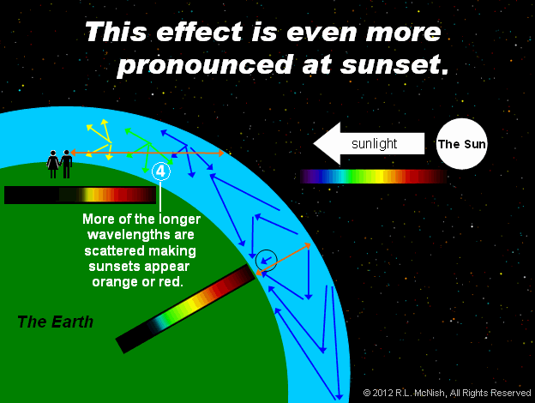

As the sun gets lower in the sky, the light passes through much more air, which scatters out more and more of the short wavelengths, leaving the longer wavelengths to pass straight through. This makes the sun look more red when it is on the horizon.

Q: What is special about blue light that makes it get scattered?
A: Here’s some math! (Don’t freak out.)
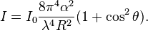
Rayleigh scattering occurs from individual molecules. Here the scattering is due to the molecular polarizability α, which describes how much the electrical charges on the molecule will move in an electric field. In this case, the Rayleigh scattering intensity for a single particle is given by^{[4]}

The strong wavelength dependence of the scattering (∝λ⁻⁴) means that shorter (blue) wavelengths are scattered much more strongly than longer (red) wavelengths. This results in the indirect blue light coming from all regions of the sky.
Note that since scattering is inversely proportional to the fourth power of the wavelength, that if wavelength doubles, then scattering drops by a factor of 2⁴, so the scattering of 700 nm light is only 1/16th as great as the scattering of 350 nm light.
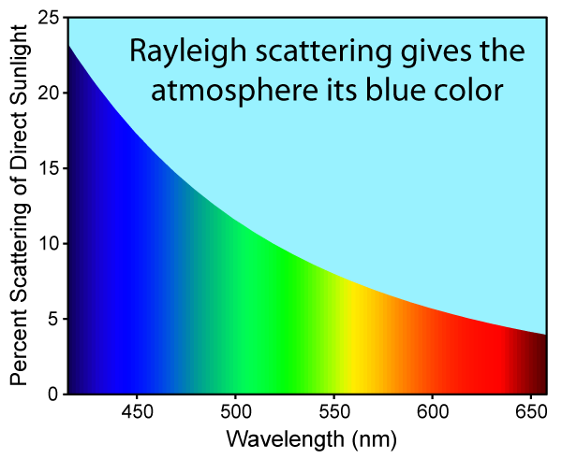

Q: If purple gets scattered more than blue, why isn’t the sky purple?

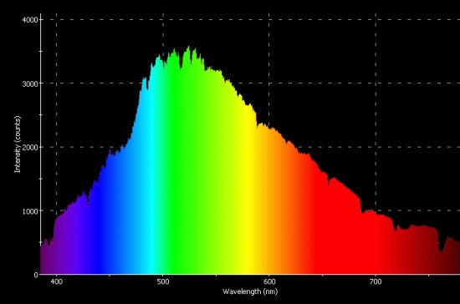
A: Here is the visible portion of the spectrum of the sun. Notice that there is very little violet which is emitted by the sun, relative to other colors such as green, blue, and yellow.
The blue light gets scattered, coming at us from all portions of the sky. The green, yellow, and red get through, and our eyes and brains average out those colors so we perceive yellow.

When the sun is closer to the horizon, and the light passes through more of the earth’s atmosphere, more of the green also gets scattered out. This leaves the sun’s light looking more orange or red, but also leaves the sky looking even more blue/purple.

Q: Why does the sun send out the colors it does?
A: It closely matches the “Black-body Radiation” curve for an object
If we take a closer look at the actual black-body curve, we see an anomalous overshoot in the blue band.
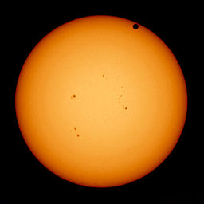
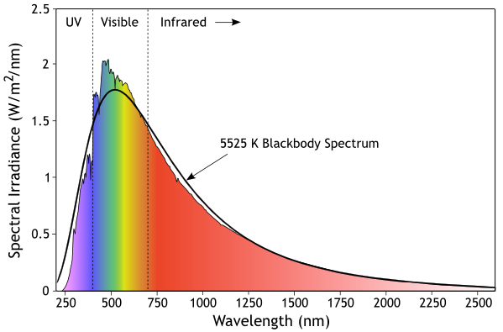
Figure 11. The Sun with Venus in transit, courtesy Solar Dynamics Observatory.

The reason for this is that the spectrum is actually a blend of blackbody curves from plasma at different temperatures. The light that we receive from the edge of the Sun is 4600 K, while the light coming straight out at us is 6400 K. (SeeFigure 11.) Hence the 5525 K fit is actually just an average of temperatures that vary from 4600 to 6400 K.
This so-called "limb darkening" proves that hotter light has to be coming from deeper in the Sun, and that nearer the surface, the temperature is cooler. The reason is that photons from deeper in the Sun have to traverse a lot more plasma when coming at us from the edge, and more of the light gets scattered. Cooler light from nearer the surface still makes it through, because it doesn't have to pass through as much plasma to get above the surface.

