Hair Notes
Most of the human body is covered in hair. Human hair comes in different shapes and forms – it can be head hair, beard hair, chest, arm, arm pit, leg, facial, pubic, ear, nose or anal hair. These hairs can be in a growing (anagen) phase, while others grow and then go into a resting (catagen) phase. Other hairs are in a dying (telogen) phase and will eventually fall out. The follicle is what holds a hair in place. The root is embedded in the follicle of the skin. Hair also grows from the follicle. Most of the hair is not alive and is not made of cells. Most of the hair shaft is made of protein.
A piece of hair has 3 main parts (longwise) – The root, the hair shaft, and the tip of the hair
The shaft of the hair also has 3 main parts – The outside cuticle (scales), the cortex, and the inner medulla.

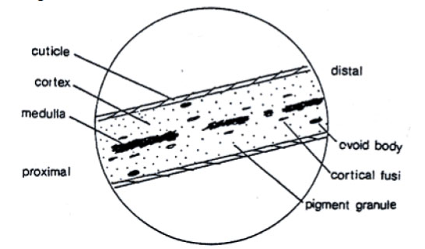
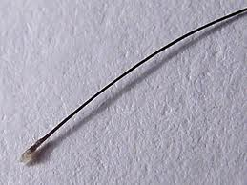
The cortex of the hair has both pigment granules (melanin) and cortical fusi (air sacs). These work together to give hair its color and appearance. The more melanin hair has, the darker it is. The more cortical fusi hair has, the lighter it appears.
Melanin

https://www.google.com/url?sa=i&rct=j&q=&esrc=s&source=images&cd=&cad=rja&uact=8&ved=2ahUKEwjNsfj9i4LfAhXNm-AKHXmBDMkQjRx6BAgBEAU&url=https%3A%2F%2Fwww.crimemuseum.org%2F2009%2F10%2F12%2Fwhat-can-you-tell-from-forensic-hair-examination%2F&psig=AOvVaw0hRU4-68nh4GbnBRCS4yXV&ust=1543872407537373

Hair can be a valuable piece of evidence at a crime scene. It can provide a link between the suspects and the victims. It can also indicate where a victim has been. Animal hairs can also be used to help solve crimes. The most common animal hairs left at crime scenes belong to pets like dogs and cats. Even though hair is usually classified as class evidence (can only narrow it down to a group of people or things), it can become individualistic in these cases:
- The person has an interesting dye pattern/color in their hair. Often the roots of a person’s hair are a different color than the dye in the hair. People often have more than one color dye in their hair at a time also.
- The person suffers from a disease that affects the structure of their hair
- Serologists find a root. The root is the only part of hair that has DNA inside it
Classic root patterns:
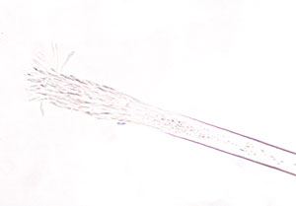
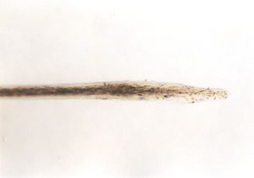
Spade Frayed
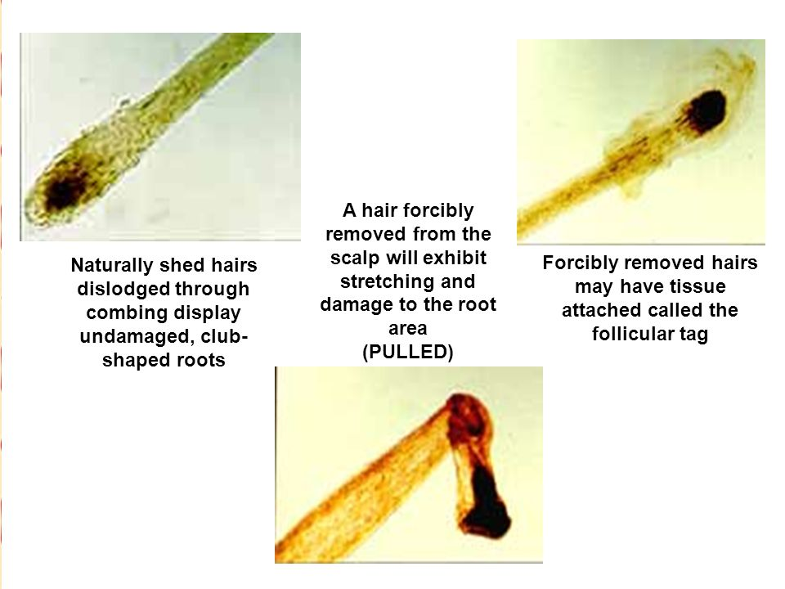
https://www.google.com/url?sa=i&rct=j&q=&esrc=s&source=images&cd=&cad=rja&uact=8&ved=2ahUKEwjO7eWqkoLfAhXGT98KHXC8Dc4QjRx6BAgBEAU&url=https%3A%2F%2Fwww.fbi.gov%2Fabout-us%2Flab%2Fforensic-science-communications%2Ffsc%2Fjuly2004%2Fresearch%2F2004_03_research02.htm&psig=AOvVaw2fXR-K6BkC88rz7cX95N0E&ust=1543874105998584
https://www.google.com/url?sa=i&rct=j&q=&esrc=s&source=images&cd=&cad=rja&uact=8&ved=2ahUKEwiX-vfbkoLfAhXiSt8KHfQPBLMQjRx6BAgBEAU&url=https%3A%2F%2Fwww.fbi.gov%2Fabout-us%2Flab%2Fforensic-science-communications%2Ffsc%2Fjuly2004%2Fresearch%2F2004_03_research02.htm&psig=AOvVaw2fXR-K6BkC88rz7cX95N0E&ust=1543874105998584 https://www.google.com/url?sa=i&rct=j&q=&esrc=s&source=images&cd=&cad=rja&uact=8&ved=2ahUKEwjhn8DJk4LfAhXMc98KHaCmC0cQjRx6BAgBEAU&url=https%3A%2F%2Fslideplayer.com%2Fslide%2F7480789%2F&psig=AOvVaw0V6QAvHcqSyht1NCqalatM&ust=1543874541459467
Classic cuticle (scale) patterns:
https://www.google.com/url?sa=i&rct=j&q=&esrc=s&source=images&cd=&cad=rja&uact=8&ved=2ahUKEwiUmsDgl4LfAhUGSN8KHdN5CwAQjRx6BAgBEAU&url=https%3A%2F%2Fslideplayer.com%2Fslide%2F4315850%2F&psig=AOvVaw1a1AXQOsyfzs7BHv67mvno&ust=1543875808694313

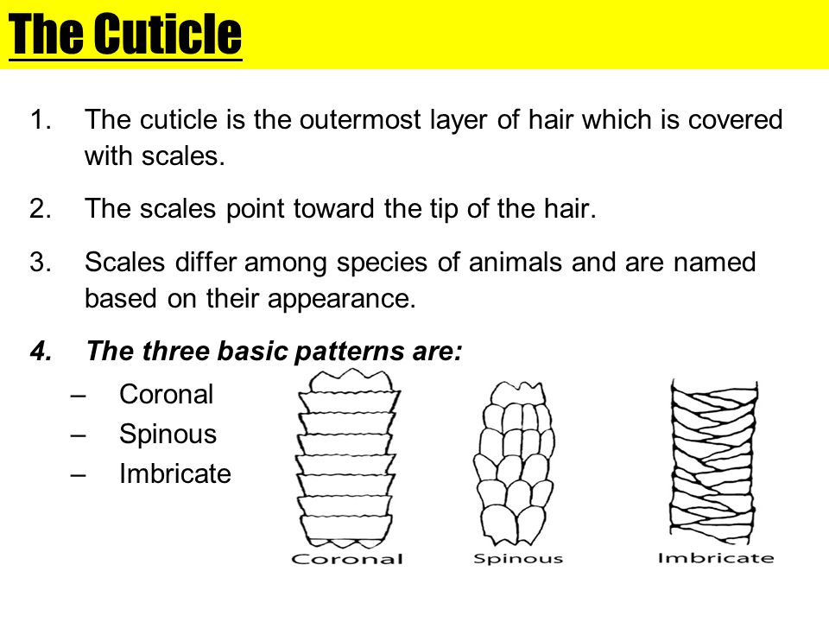

Typical Medulla Patterns:
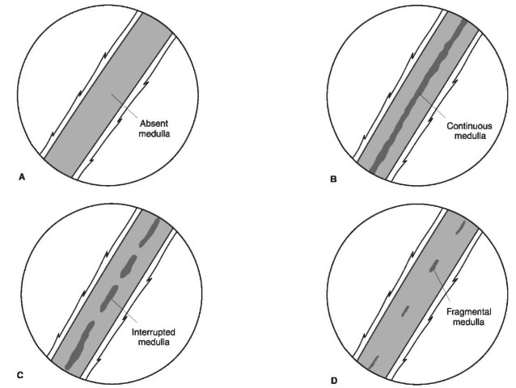
The medulla is considered to be uniserial if there is only one row or series of medulla like the ones shown on the left.
If there is more than one row or series of medulla, it is considered to be multiserial. See Below
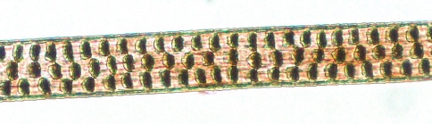
Or discontinuous

