Class/Subject: Philosophy | Lesson 10- “Ship of Theseus”
Objective(s):  SWBAT create criteria on what constitutes authenticity and apply it to a variety of facets in life. SWBAT also buttress their criteria using classic philosophical examples. | Unit: Epistemology
Philosophical Quote of the Day:  “What we achieve inwardly will change outer reality”.  -Plutarch | Philosophical Song of the Day:  “Keeping It Real”- Shaggy https://www.youtube.com/watch?v=hmTOM2fuFwk
Key Points of the Day:  • Authenticity is something that must be explored and quantified. This applies to material items, relationships, and the self. | - The Ancient Greeks explored this with the Ship of Theseus and the introspection continued through the ages from John Locke to the modern slang, “keeping it real”. Locke coined the term, “real essence” in 1689.
Journal Entry:  “What are your criteria to what is real, what is the value in evaluating authenticity? What applications does evaluating authenticity have in your everyday life?” | Supplemental Reading: “Theseus” by Plutarch  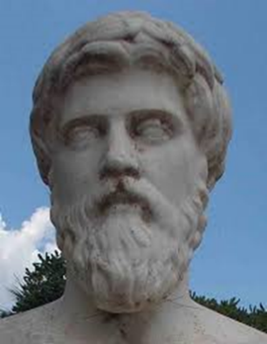  Plutarch was a Greek historian, biographer, and essayist, known primarily for his Parallel Lives and Moralia. Along with Aristotle, he is considered one of the most influential philosophers of Western thought.

