Unit 7 Investigation Poster Template- Make sure your poster contains the following…..
- Your three agreed-upon criteria for evaluating quality of life. | - Your rationale in one paragraph to why you chose what you chose in section 1.
- A Venn Diagram comparing the lives of hunter-gatherers to those of agriculturalists.  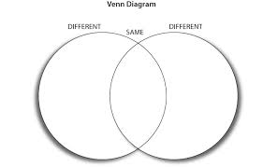 | - A summary of your conclusions about whether hunter-gatherers or agriculturalists had the better quality of life.

