Name:_________________________ Date:_________ Hour:_____ Assignment#____
CALCULATING POSITION, DISTANCE, DISPLACEMENT
Diagram A: The diagram below shows the position of a skier and the distance traveled from one point to another. Follow his path from A to D and answer the questions below. Initial position is 0 meters.
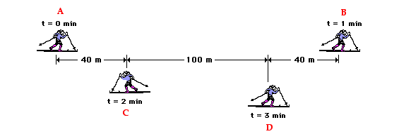

1) The number line in the diagram has been split up to show distances traveled between letter positions. Looking at all the distances given, what is the total length of the number line in meters? ____________
2) Which letter represents the skier’s initial position? _______________ What is the skier’s initial position in meters? _______________
3) Which letter represents the skier’s final position? _________________ What is the skier’s final position in meters? ________________
4) For each interval below, identify the distance traveled.
A B (add the distances between A and B) _____________
B C (add the distances between B and C)_____________
C D (the distance between C and D) _____________
5) Using the information about the distances traveled in problem 4, what is the total distance traveled by the skier (ABCD) ?____________________
6) What is the skiers displacement? (***The distance between final (D) and initial position (A) and the direction!) ______________________
7) Now draw vectors on the diagram that would represent the magnitude and direction traveled by the skier between each interval! (In other words draw an arrow from A to B and label that arrow with the distance traveled. Do the same for B C, and CD)
Diagram B: As another example, consider a football coach pacing back and forth along the sidelines. The diagram below shows several of coach's positions at various points. At each marked position, the coach makes a "U-turn" and moves in the opposite direction. In other words, the coach moves from position A to B to C to D.
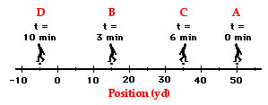

1) Which letter represents the coach’s initial position? _______________ What is the coach’s initial position in yards? _______________
2) Which letter represents the coach’s final position? _________________ What is the coach’s final position in yards? ________________
3) For each interval below, identify the distance traveled.
A B (# of yards traveled from A to B) _____________
B C (# of yards traveled from B to C)_____________
C D (# of yards traveled from C to D)_____________
4) Using the information about the distances traveled in problem 3, what is the total distance traveled by the coach (ABCD) ?____________________
5) What is the coach’s displacement? (***The distance between final and initial position AND the direction!) ______________________
6) Now draw in vectors on the diagram that would represent the magnitude and direction traveled by the coach at each interval. (In other words draw an arrow from A to B and label that arrow with the distance traveled. Do the same for B C, and CD)

Measuring Distance and Displacement
There are ten stations each with a different pathway set up. For each station:
a) Make a sketch of each pathway on your blank paper with the correct number next to it.
b) Label all points shown. (A, B, etc)
c) Measure each vector in centimeters AND label the vectors on your sketches with their magnitudes (measurements).
d) Measure the displacement in centimeters AND draw a vector on your sketch that shows displacement from starting point to ending point. Label this vector with distance and direction.
***For directions, use
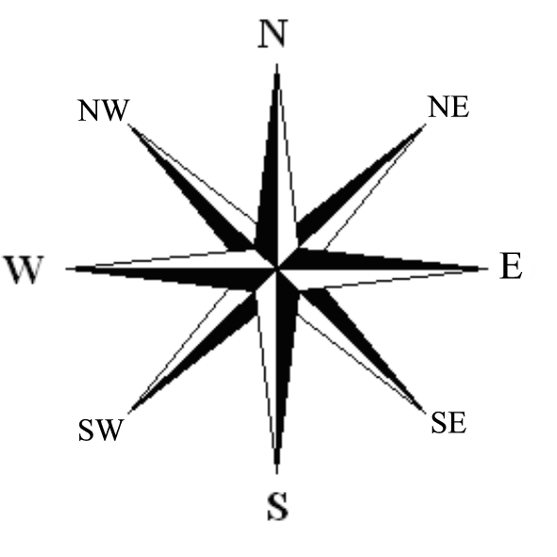

e) Next to each sketch on your paper include : Total distance_________________
Displacement______________
See example below:
25 cm
1
B
C
32 cm NE
20 cm
A

Total distance: 45 cm
Displacement: 32 cm NE
Measuring Distance and Displacement

1) 2)

3) 4)

5)

6) 7)

8) 9)

10)

