Class/Subject: Philosophy | Lesson 18: “Finding Joe Film”
Objective(s):  SWBAT self-reflect on what constitutes a beautiful and authentic life through watching the film, “Finding Joe”. SWBAT also answer questions that incorporate what they’ve gleaned from introspection and discussion. | Unit- “AESTHETICS”
Philosophical Quote of the Day:  “Life has no meaning. Each of us has meaning and we bring it to life. It is a waste to be asking the question when you are the answer.” ― Joseph Campbell | Philosophical Song of the Day:  In addition to the film, “Finding Joe” obviously, a short clip from Joseph Campbell on bliss, https://www.youtube.com/watch?v=TLKUFYAOoRI
Key Points of the Day:  - Joseph Campbell was a professor who created a theory that all human stories followed the same pattern. This is known as the monomyth, or “Hero’s Journey”. It was his belief that you can take any story and chart it. Essentially, there is one human story. | - Joseph Campbell gave advice to, “follow your bliss”, as a means to create a beautiful and authentic life.
Journal Entry:  In lieu of a journal, students will answer the question packet related to the movie. | Featured philosopher and supplemental reading: “The Power of Myth”, Joseph Campbell  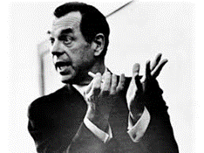  Joseph John Campbell was an American mythologist, writer and lecturer, best known for his work in comparative mythology and comparative religion. His work is vast, covering many aspects of the human experience.

