ChemQuest 2
Intro to Graphs
Name: ____________________________
Date: _______________
Hour: _____

Information: Types of Graphs

Pie Graphs Bar Graphs Line Graphs
How does this variable change over time?
How different are these variables to each other?
What portion of the total does each part make up?

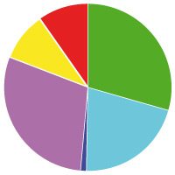
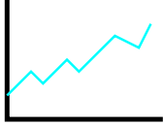
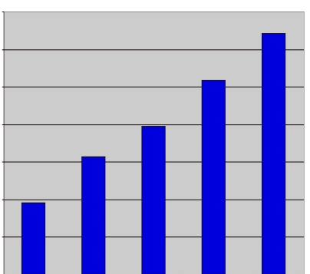

Critical Thinking Questions

- Over half (53%) of all tablet computers sold are made by Apple, inc. Almost one fourth (23%) are made by Amazon. Google (13%) and Samsung (11%) tablets combine for the other fourth. Of the three types of graphs, which type of graph do you think would be the most helpful at communicating this information?

- Last month, Apple sold 4 million iPhones. Motorola sold 2 million Droids. HTC sold 3 million Evo phones. Which type of graph would be most helpful in presenting this information?

- In January, Apple sold 2.4 million iPhones. In March, Apple sold 1.2 million iPhones. May sales were extra strong with 18.2 million iPhones being sold. In July, the company sold 14.4 million. Apple sold 3.1 million iPhones in September and 2.2 million in November. Which type of graph would be most helpful in presenting this information?
- Consider the following graphs. Which is the most meaningful?

Graph A Graph B Graph C
Employment in Hicktown

- The answer to the previous question was probably obvious. When evaluating a good graph, what are things you look for?

- Below are two graphs using the data from question 2.
Graph A Graph B
1
2
3
4
1
2
3
4

  - Which of the graphs do you find to be the most helpful and easy to read? Why?

  - The y-axis (vertical) contains the numbers 1-4 but it does not have labeled units. If you were making the graph, which of the following labels would you use? (Add your labeled units to the graph you chose in part a.)
    - number of phones sold
    - number of phones made
    - dozens of phones sold
    - millions of phones sold

  - The x-axis isn’t labeled at all. Add labels to the x-axis of the graph you chose in part a.
  - Write a title for the graph. Your title should be a short phrase that describes what the graph is trying to tell someone.
Information: Drawing Good Graphs

In questions 5 and 6 we definitely see important characteristics of good graphs.

The “Good Graph Checklist”:
- Descriptive titles!
- Labels!
- Graph takes up most of the graph paper!

Critical Thinking Questions

- Consider the data given in question 3. Also consider your answer. Hopefully you chose a line graph as the best type of graph for the data. A line graph is the best choice when you want to represent what happens over a period of time. In this case, we are trying to represent how the sales of iPhones changes over time. Use the data in question 3 to draw your own line graph below. Make sure you label the x and the y axis and give your graph a title.

- From your graph, estimate the number of iPhones sold in August.

- Usually when Apple starts selling a new iPhone many more people purchase them. At the beginning of one of the months, Apple started selling a brand new version of the iPhone—which month do you think it was?
Information: Platinum and Catalytic Converters

A catalytic converter is a device in the exhaust system of an internal combustion engine used to convert toxic byproducts of combustion into safer, less toxic substances. Platinum metal is used as a catalyst in these devices. As an example of what the catalytic converter does, carbon monoxide (CO), a poisonous gas, is changed into carbon dioxide (CO₂). The chemical reaction is shown below:
2 CO + O₂ 2 CO₂

The presence of platinum metal helps the O₂ react with the CO faster than it otherwise would. It is as if the platinum holds the carbon monoxide molecule in place so that the oxygen can react with it and convert it into carbon dioxide.

Over time, the platinum in the catalytic converter wears away. Scientists can measure the output of carbon monoxide from a vehicle by checking the vehicles emissions. Most state regulations require the emissions of carbon monoxide to be below 15 parts per million (ppm).

Figure 1: Platinum Wear and Carbon Monoxide Emissions Over Time
Key
= percent platinum remaining

= carbon monoxide emissions

100 20

Carbon monoxide emissions
(ppm)
90 15
Percent platinum remaining

80 10

70 5

1 2 3 4 5 6 7 8 9 10
Age of catalytic converter (years)

Critical Thinking Questions

- According to the graph, what happens to the amount of carbon monoxide emitted from a vehicle over time?

- When the catalytic converter is 9 years old, what percent of platinum remains in it?
- How does the drop in platinum between years 1 and 2 compare to the drop in platinum between years 9 and 10?

- At approximately what year does the amount of carbon monoxide emitted cross the legal limit?

- According to the passage, what might be a definition for “catalyst”?

- Using the data, what is one hypothesis for why carbon monoxide emissions increase over time?

Information: Comparing CO Emissions

Consumers were interested in the carbon monoxide emissions from different vehicles. Consumers wanted to know how much carbon monoxide was emitted from different new cars during the first year and how the mileage driven affected the emissions. They also wanted to know if the octane level of the gasoline affected the emissions. Studies were done and the data was summarized in the following graph.

Key:
Toyota = 5 parts per million CO
Sedan

GM
Sedan

Ford
Sedan

87 89 92
15000
10000
5000
Octane fuel

Miles driven in 1st year
Critical Thinking Questions

- The above graph is a type of _____________________________ .
line graph, pie graph, or bar graph?

- There was no difference in carbon monoxide emissions between 87 octane and 89 octane gasoline for which type of sedan—Toyota, GM, or Ford?

- Driving more miles in the first year caused an increase in carbon monoxide emissions for all but which one of the sedans—Toyota, GM, or Ford?

- Which kind of sedan had the least CO emissions when driven 10,000 miles the first year—Toyota, GM, or Ford?

- To make sure your vehicle is emitting the least amount of carbon monoxide you should
    - Drive as little as possible and use the lowest octane fuel available.
    - Use high octane fuel and drive more miles.
    - Drive few miles and use higher octane fuel.

