Class/Subject: Philosophy | Lesson 9: “Descartes’ Demon/Brain in a Vat”
Objective(s):  SWBAT evaluate the nature of knowledge, reality, truth, mind, and meaning by engaging in the Descartes’ Demon/Brain in a Vat thinking exercises. | Unit: Epistemology
Philosophical Quotes of the Day:  “I think, therefore I am” – Rene Descartes  “As if I didn’t remember other occasions when I have been tricked by exactly similar thoughts while asleep! As I think about this more carefully, I realize that there is never any reliable way of distinguishing being awake from being asleep. This discovery makes me feel dizzy, which itself reinforces the notion that I may be asleep!” –Rene Descartes | Philosophical Song of the Day:  “I Know What I Know”- Paul Simon https://www.youtube.com/watch?v=4w3CBdLfGqw
Key Points of the Day:  • The Brain in a Vat thought-experiment. You are told to imagine the possibility that at this very moment you are actually a brain hooked up to a sophisticated computer program that can perfectly simulate experiences of the outside world. | • Here is the skeptical argument. If you cannot now be sure that you are not a brain in a vat, then you cannot rule out the possibility that all of your beliefs about the external world are false. Or, to put it in terms of knowledge claims, we can construct the following skeptical argument. Let “P” stand for any belief or claim about the external world, say, that snow is white.  • If I know that P, then I know that I am not a brain in a vat  • I do not know that I am not a brain in a vat  • Thus, I do not know that P.
Journal Entry:  “Recap the significance of these epistemological concepts and write what they say about the nature of knowledge, reality, truth, mind, and meaning.” | Supplemental Reading: “The Matrix and Philosophy” by: William Irwin  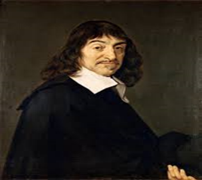  Descartes was a French philosopher, mathematician and writer. He has been dubbed the father of modern philosophy, and much subsequent Western philosophy is a response to his writings,

