Class Notes: Atomic Models
Democritus= 400 B.C. – said the world was made of two things: empty space and tiny particles called “atoms”
--said atoms were the smallest particles of matter, and said there were different types of atoms for each material in the world
Atom = the smallest part of an element that still has the properties of that element
Dalton – developed Dalton’s Atomic Theory – 4 parts:
1. Elements are composed of indestructible particles called atoms
2. All atoms of an element are identical to each other and different from the atoms of another element
3. “Law of Multiple Proportions”: Atoms combine in whole number ratios to form compounds (can’t have half an atom)
4. In chemical reactions, atoms are joined, separated, or rearranged, but never changed into different kinds of atoms
2. Thompson – “plum pudding” – *discovered the electron using cathode ray tube experiment, and said that electrons were dispersed throughout a lump of protons
3. Rutherford – electrons surround a dense nucleus of protons and neutrons
Rutherford’s Gold-Foil Experiment: gave evidence of the atomic nucleus
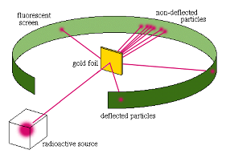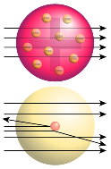
4. Bohr – planetary model = electrons follow fixed orbits around the nucleus with a fixed amount of energy
Can change energy level if a set amount of energy is lost or gained
5. Schrodinger and Heisenberg –mathematical models - there is a set number of electrons, but they follow no fixed path, don’t know their location or velocity/momentum
**Electron cloud – a cloud of negative charge surrounding the nucleus

