States of Matter and Phase Changes - Notes
Matter: anything that has volume and mass
3 states of matter: defined by motion of particles (kinetic energy)
- Solids: fixed shape (slow motion), definite volume, not easily compressed (can’t be squeezed), little expansion when heated, low Kinetic energy and motion of particles, strong intermolecular forces
- Liquids: fluid shape (medium motion), definite volume, not easily compressed, little expansion when heated, intermediate intermolecular forces, can flow, takes on shape of container
- Gases: shape varies (fast motion), indefinite volume, easily compressed, expands at any temperature. Lots of kinetic energy and particle motion. Increases temperature leads to increased pressure on the container
*NOTE: These are not all the characteristics we talked about in class.
Phase changes (Physical changes)
Evaporation (vaporization) – liquid gas
Melting – solid -> liquid
Freezing – liquid -> solid
Condensation – gas ->liquid
Sublimation – solid -> gas
Deposition – gas -> solid
Which of these are endothermic reactions? Which are exothermic? How do you know?
Kinetic Molecular Theory
- Matter is made up of particles
- The particles are always moving (Kinetic energy is the energy of movement)
*An increase of temperature leads to an increase in kinetic energy
Phase change graphs – can show exothermic or endothermic reaction and phase changes (can go backwards and forwards)

What does this graph mean? What is happening at each stage?

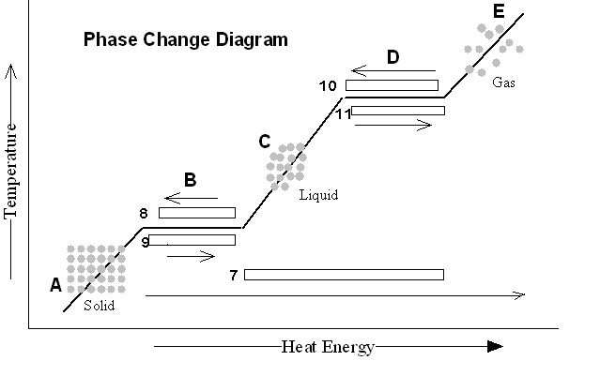

L
Phase changes are physical changes. What is evidence of a chemical change? Can you differentiate between physical changes in matter and chemical changes in matter?
Law of Conservation of Matter – says that matter can neither be created nor destroyed. For example, the liquid above turns into a gas, it doesn’t totally disappear (not a magic trick!)

