Oceania: “The Other 1/3 of the World”
- Watch the video I created on Oceania. Take notes on key points I make and enjoy the two minutes of rugby bliss. https://youtu.be/-FNhPAFBQYI

- Fill in this map of Oceania:

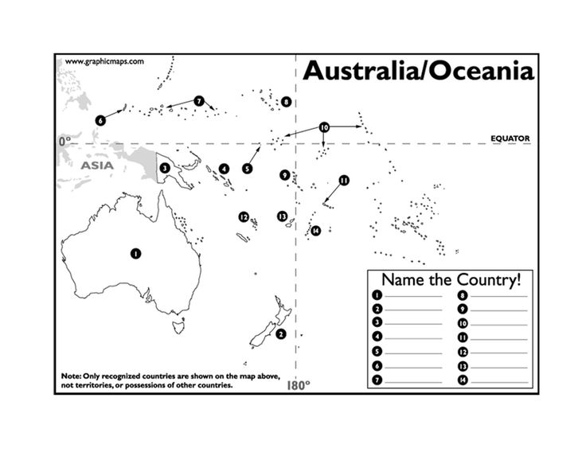
- Read this article on the Moai of Easter Island: http://tinyurl.com/7sctqg8. What is the theory of how they got there?

Turn this into the bin when you’re done.

