The Four World Zones, Cynthia Stokes Brown

Climate and geography divide human populations
For a brief period, from about 10,000 years ago to about 500 years ago, the rising seas at the end of the last ice age divided the world into four non-connected geographic zones. Isolated from one another, four groups of people developed distinct lifeways and conducted their own experiments in human culture.

What are world zones?
In his book Maps of Time, David Christian describes the division of the world into four world zones, which helps him analyze and explain human history. Many other historians have recognized the two largest world zones — Afro-Eurasia, which they often call the “Old World,” and the Americas, which they call the “New World.” But Christian was living in Australia, and preferred looking at the whole world. These are the four world zones that he uses:
01 - Afro-Eurasia: Africa and the Eurasian landmass, including offshore islands like Britain and Japan
02 - The Americas: North, Central, and South America, plus offshore islands like the Caribbean Islands
03 - Australasia: Australia and the island of Papua New Guinea, plus neighboring islands in the Pacific Ocean
04 - The Pacific: Island societies such as New Zealand, Micronesia, Melanesia, Hawaii
(Antarctica is not considered a world zone because until very recently no people lived there.)
A world zone is simply a large region of human interaction, linked geographically, culturally, economically, and sometimes politically. It may have a hundred thousand to millions of people living in different types of communities. Each of the four world zones functioned as a separate world, not in regular contact with other zones until Europeans sailed to the Americas late in the 15th century. The world today no longer has four separate world zones — our world is increasingly global.
For most of human history, humans existed only in Afro-Eurasia. Homo sapiens migrated to Australasia about 60,000–50,000 BCE and to the Americas about 20,000–15,000 BCE. Human interaction continued among these three areas until the melting at the end of the Ice Age caused sea levels to rise sufficiently to drown the land bridge between Asia and the Americas. There never was a land bridge between Australasia and Afro-Eurasia; a significant sea passage always existed, which is why the arrival of humans in Australasia seems such an achievement. But the passage between Afro-Eurasia and Australasia became wider, and harder to cross, after the seas rose.
The rising of the seas occurred sometime after humans got to the Americas, creating three separate world zones. The fourth world zone, the Pacific Islands, did not emerge until humans became skilled enough at sailing to reach these islands — sometime in the past 4,000 years. Hence three of the four world zones operated from about 10,000 BCE to about 1500 CE, while the fourth functioned only from about 2000 BCE to 1500 CE. After 1500 CE, extensive travel by sea connected all of the zones and established the first global exchange network.
What the four world zones reveal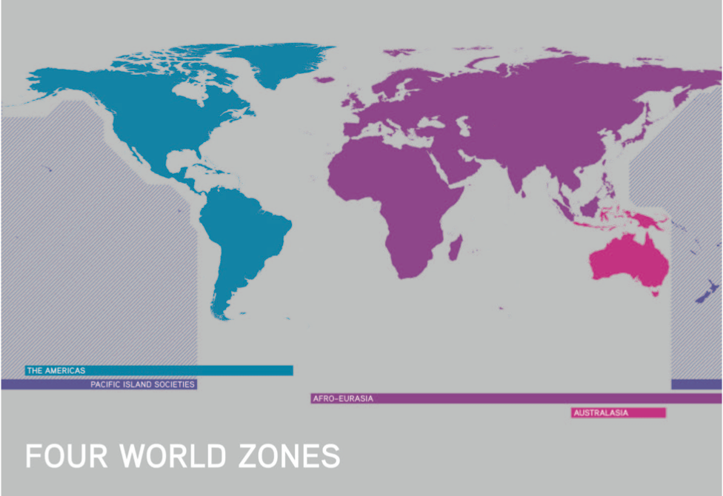
The rising seas cut off the four groups of humans from each other long enough for them to develop different experiments in culture and civilization, but not so long that they would develop into separate species. How amazing is that?
Comparing human societies is a bit like deciding whether a glass is half full or half empty. You can notice how different human societies are from each other, or you can exclaim how similar they are to one another. World history and anthropology courses usually focus on the differences in human societies in the four world zones. Big history courses focus instead on the similarities of different human societies, even though they were completely separated from each other for quite a long period.
Agrarian civilizations emerged only in the two largest world zones for very specific reasons. A closer look at the four zones demonstrates that some zones had more advantages than others. Afro-Eurasia was so much larger, with better plants for food and animals better suited for transportation, that civilization emerged there several thousand years earlier than in the Americas. This gave peoples from Afro-Eurasia a decisive edge when they arrived in the Americas and found civilizations similar to theirs in structure, but earlier in their development.
The smaller two world zones were so much smaller in their habitable land mass, available resources, and population that they did not reach the density of people required for civilization in the time allowed. On the larger Pacific islands, like Hawaii and New Zealand’s North Island, agriculture emerged, and something very close to states. Would these societies have become states/civilizations if they had not been interrupted by conquest from the larger zones? We can never know.
In most areas of the Australasian world zone people remained foragers until the arrival of the Europeans. Agriculture did emerge in the highlands of Papua New Guinea, but their root crops could not be stored in large quantities and villages were not easily connected. Hence, political structures beyond village life did not emerge. On the Australian mainland, widespread agriculture never developed. Soil was poor and, by chance, the available species of plants were not easy to domesticate. Still, archaeological sites show that the population was increasing in the two millennia before Europeans arrived.
When you compare the four zones, it’s easy to see the advantages that people living in Afro-Eurasia had over the other regions. Its people had a head start with the earliest human habitation, the greatest geographic area, and the largest population. Afro-Eurasia also had the most varied resources and the largest networks of collective learning, which contained more — and more diverse — information than those networks existing in the smaller zones.

