Day 102: “The Other”: A Key Component in Nationalism
In classical sociology, "other" is a concept in the study of social life through which we define relationships. This applies on all scales and we will explore them today. When exploring, don’t state surface differences i.e. “USA is in North America and North Korea is in Asia”, or, “I’m a short Black girl, so the tall White guy is my other”. Go deeper than that and focus on values, norms, mores, customs, and identity. Type this up and send it to me at Anthony.salciccioli@clarencevilleschools.org when you compete the drill.
Scale 1: Personal
- Q: Think of a person who is the most opposite of you. What about them makes them so different from you?

A:
Scale 2: School
- Q: Think of two teachers that are the most opposite from each other. What makes them so different?

A:

- Q: What school is the opposite of Clarenceville? How are they different than us?
A:
Pretty easy, huh? Time to get more academic……
Scale 3: United States History
Explore the following primary sources. Primary sources can take many forms, but serve as the purest form of history, because you can interpret them for yourself. I want you to look at the sources and fill in the table below with the time frame it took place, who the other was at that time, and the image it created.
Source | What time? | The “other” of this time | Perception created of the other:
1
2
3
4
5
6
7
8
9 | Today

Source 1 (Journal Entry): “The enemy set fire to Deacon Joseph Loring's house and barn. Mrs. Mulliken's house and shop, and Mr. Joseph Bond's house and shop, all of which were consumed. They also set fire to several other houses, but our people extinguished the flames. They pillaged almost every house they passed by, breaking and destroying doors, windows, glasses &c and carrying off clothing and other valuable effects. It appeared to be their design to burn and destroy all before them, and nothing but our vigorous pursuit prevented their infernal purposes from being put into execution. But the savage barbarity exercised upon the bodies of our unfortunate brethren who fell is almost incredible. Not content with shooting down the unarmed, aged, and infirm, they disregarded the cries of the wounded, killing them without mercy, and mangling their bodies in the most [missing] manner. We have the pleasure to say that notwithstanding the highest provocations by the enemy, not one instance of cruelty that we have heard of was committed by our victorious militia, but listening to the merciful dictates of the Christian religion, they breathed higher sentiment of humanity. (http://www.loc.gov/exhibits/british/brit-2.html#obj7)
Source 2 (Political Cartoon): http://hdl.loc.gov/loc.pnp/cph.3b53091

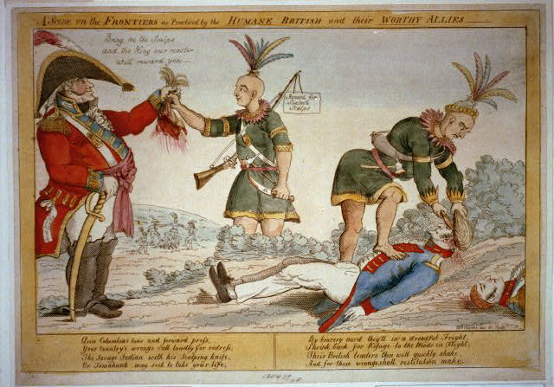

Source3 (Map and Painting): This is what America took:
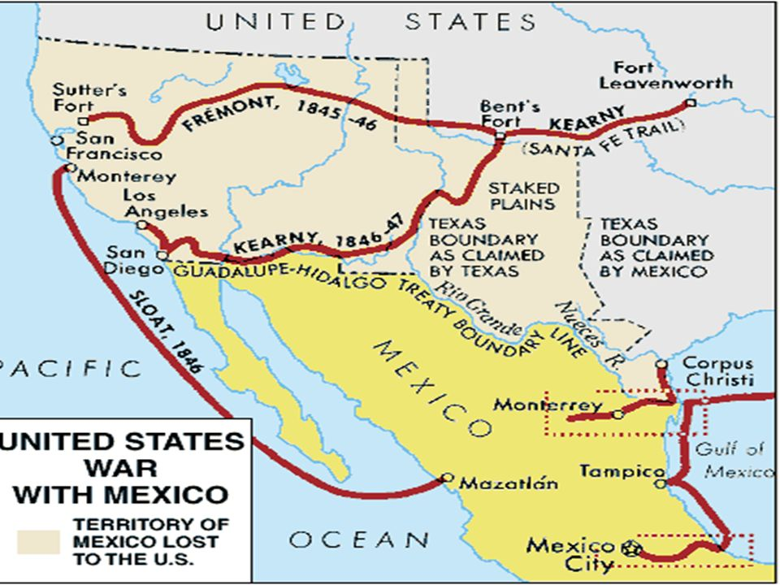
…..and justified it by this: http://www.thealamo.org/index.html
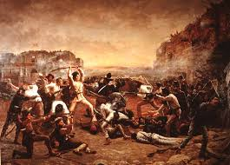

Source 4 (Propaganda Posters): http://www.spanamwar.com/

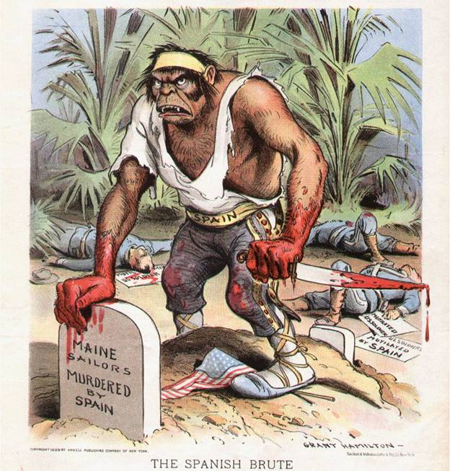
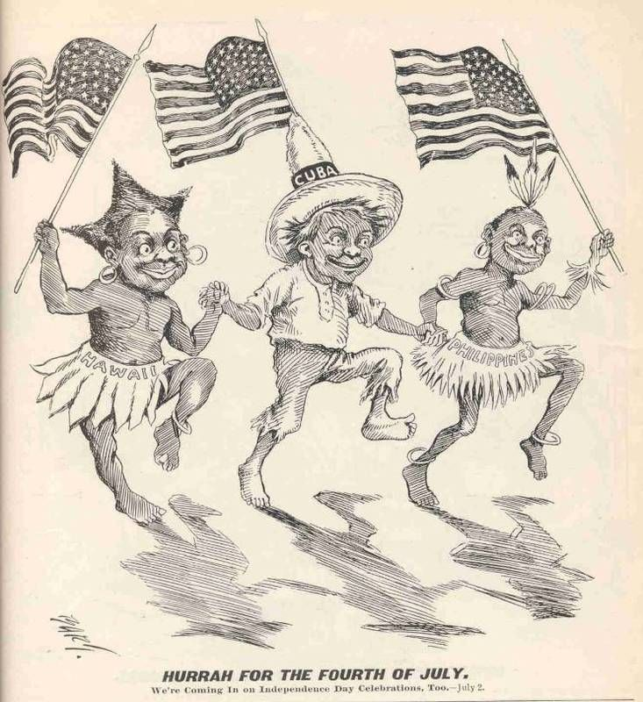
Source 5 (Newspaper):
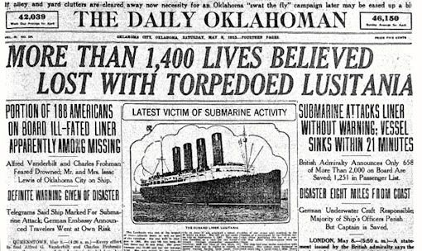
Source 6 (Magazine): http://www.english.illinois.edu/maps/poets/a_f/foster/lifemag.htm
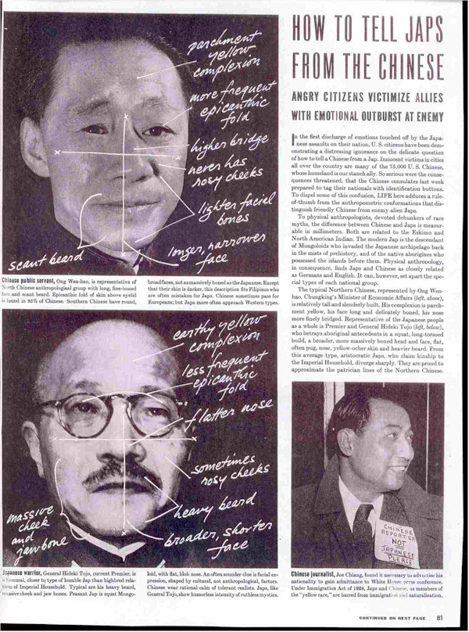
Source 7 (Films): https://www.lib.washington.edu/exhibits/AllPowers/film.html

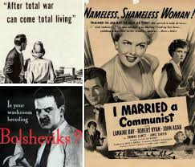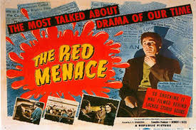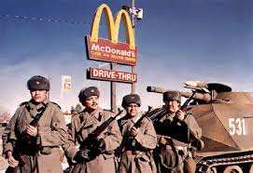
Source 8 (Political Speeches): https://www.youtube.com/watch?v=XbqCquDl4k4
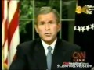
Source 9 (Find one Yourself)
Who is America’s other today? Who poses the gravest threat to what America stands for and needs to be fought against?

