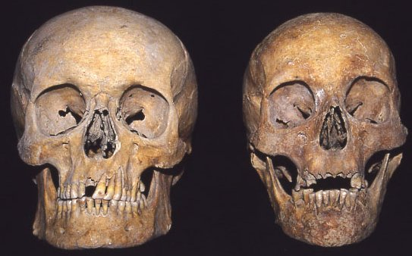
Male Female
https://www.google.com/url?sa=i&source=images&cd=&cad=rja&uact=8&ved=2ahUKEwj5zNLtiOnhAhULC6wKHWgTCosQjRx6BAgBEAU&url=http%3A%2F%2Fdentalinvestigators.blogspot.com%2F2013%2F10%2Fdifferences-between-male-and-female.html&psig=AOvVaw0A_bISLQkppneUfX0b_Y-g&ust=1556206943482152
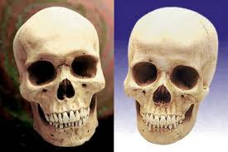
Brow ridge
Male Female
https://www.google.com/imgres?imgurl=http%3A%2F%2Fwww.oocities.org%2Ffdocch%2Fheshe.jpg&imgrefurl=http%3A%2F%2Fwww.oocities.org%2Ffdocch%2Fnew2.htm&docid=1Ixd6kIMxfUPnM&tbnid=uT5OsomCL1ZQWM%3A&vet=10ahUKEwiWqb6xiunhAhVEEawKHdIKDHQQMwieAShTMFM..i&w=572&h=381&safe=strict&bih=881&biw=1280&q=pictures%20of%20male%20and%20female%20skulls&ved=0ahUKEwiWqb6xiunhAhVEEawKHdIKDHQQMwieAShTMFM&iact=mrc&uact=8
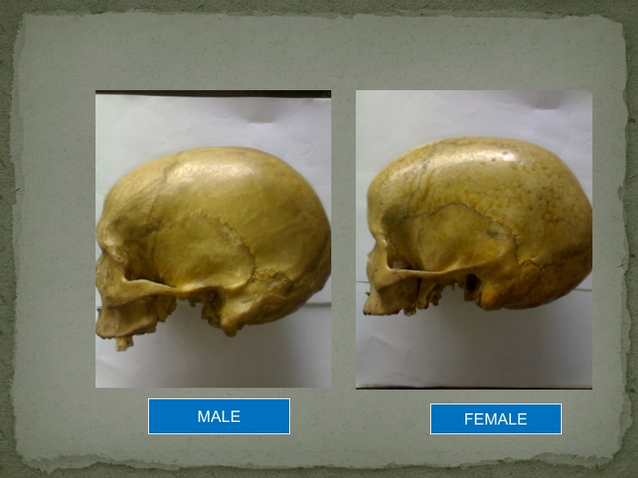
Mastoid Process

https://www.google.com/url?sa=i&source=images&cd=&cad=rja&uact=8&ved=2ahUKEwjUxrDimPXhAhUGi6wKHTuYCkUQjRx6BAgBEAU&url=https%3A%2F%2Fwww.amazon.com%2FVision-Scientific-VAL221-Medical-Numbered%2Fdp%2FB01A1E9EVK&psig=AOvVaw2DIE6iy6_sSDXO6rVAg4tn&ust=1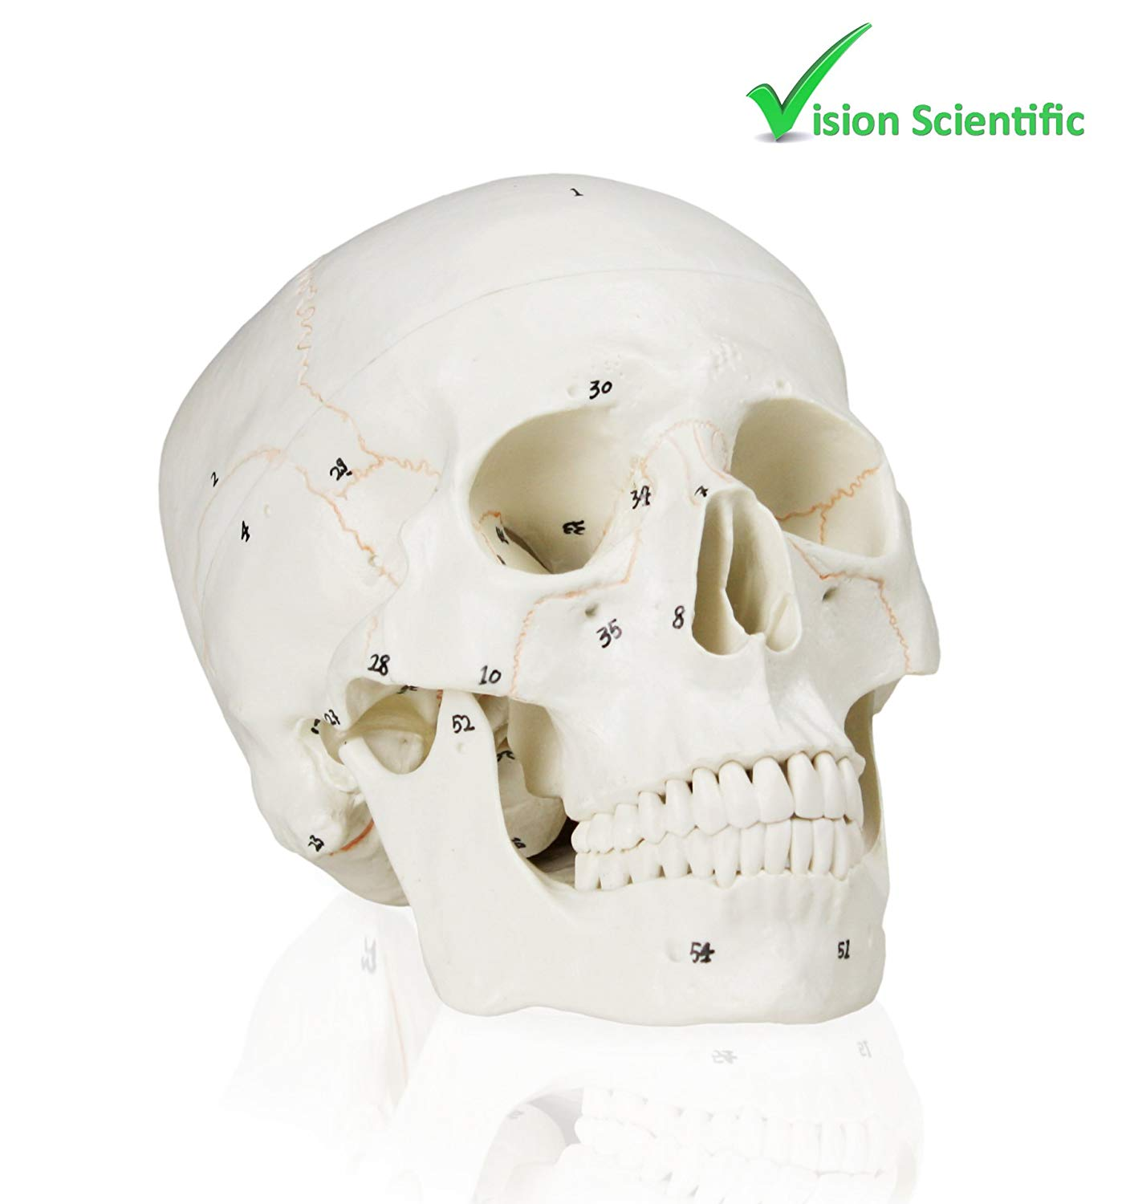
Eye Orbital (socket)
Nasal ridge (top of nose)
Nasal Spine (bottom of nose)

Zygomatic arches (cheek bones)

Maxilla (top of jaw)

Mandible (jaw bone)

