Class/Subject: Philosophy | Lesson 14: “Aesthetics as it applies to music”
Objective(s):  SWBAT use the criterion for aesthetics and use it to evaluate a variety of music. SWBAT explore types of music and critique the aesthetic merits of various songs. | Unit: Aesthetics
Philosophical Quote of the Day:  “The inexpressible depth of music, so easy to understand and yet so inexplicable, is due to the fact that it reproduces all the emotions of our innermost being, but entirely without reality and remote from its pain… Music expresses only the quintessence of life and its events, never these themselves.” -Arthur Schopenhauer | Philosophical Song of the Day:  “Angel of Music”- Andrew Lloyd Webber- https://www.youtube.com/watch?v=n7Ct4bwT4fU
Key Points of the Day:  • Music follows a similar aesthetic criterion to fine art. There is the objective, technical portion and the subjective aspects of feeling.  • Music, like other forms of art, are personal and cultural expressions that vary greatly. | - Philosophers varied in their opinions on the origins, value, and meaning of music. This debate continues on.
Journal Entry:  Choose one song that sums you up best. Take it through the 8 criteria for aesthetics and prepare to present it to the class, explaining the merits of the song. | Supplemental Reading:  “The World as Will and Representation'- Arthur Schopenhauer  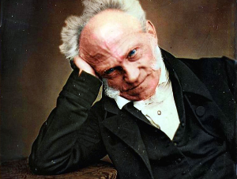  Arthur Schopenhauer (1788—1860) has been dubbed the artist’s philosopher on account of the inspiration his aesthetics has provided to artists of all stripes. He is also known as the philosopher of pessimism, as he articulated a worldview that challenges the value of existence.

