Review for Periodic Table Trends Test

- Be able to differentiate between periods and groups on the table. How many of each exist?
- How did Mendeleev arrange the table? What about Moseley?
- Be able to identify trends in atomic mass and atomic number as you move across a period and down a group
- Recognize that elements in groups/families have similar properties.
- Know the 8 major Group A families and be able to identify each
- Most of the elements on the table are metals. What are some physical properties of metals?
- Which metal is a liquid at room temperature?
- Which of the elements are non-metals and where are they located on the table?
- Which of the elements are metalloids and what does this mean about their physical properties?
- Where on the Periodic Table would you find the most reactive metals? The most reactive non-metals?
- Which group/family does not typically react with other atoms at all?
- Recognize that the periods on the table are associated with the main energy levels (quantum n)
- Recognize that the group number (A groups) on the table represents the number of valence electrons
- Know the trends that occur in periods and groups for Ionization energy, electronegativity and atomic radius. How do these relate to forces of attraction and Coulomb’s Law?
- Which element is the most electronegative element on the table?
- Be able to use the Periodic Table to write electron configurations for atoms (use s, p, d, f sub-levels i.e. 1s² 2s² 2p⁶ 3s² 3p⁶ 4s¹ etc.). Also, be able to recognize the abbreviated electron configurations for elements.
- Use your knowledge of the Periodic Table to write Lewis dot (Electron dot) diagrams showing the nuclear symbol and number of valence electrons
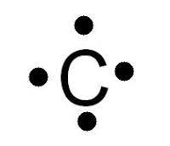
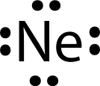
- Use the number of valence electrons to determine which atom is the most stable/least reactive 