Day 27: Introduction to Hinduism
I. DISCUSS AS A CLASS:
A) Do you think reincarnation is plausible? What do you base your rationale upon?
B) Is the American system fair to all people? Should fairness be ensured? What do you base your rationale upon?
II. WATCH VIDEO CLIPS TO ANSWER: (http://www.pbs.org/thestoryofindia/gallery/photos/2.html#sanskrit)
A) What are the Rig-Vedas and why are they significant?

B) What significance is there in the commonalities between Sanskrit and other languages? Why do you think this is?

III. READ THE MATERIALS BELOW AND HIGHLIGHT. THEN ANSWER:
A) What are the most important aspects of the reading? “Pasta from the water”.

IV. WATCH VIDEO CLIP #2 AND ANSWER: (http://www.pbs.org/thestoryofindia/gallery/photos/9.html#ghats)
A) What does the ghat burnings show about Hindu/Indian culture?

V. WATCH THE POWERPOINT AND LISTEN TO MY LECTURE AND ANSWER:
A) What is the Caste System and critique its merits.

B) What are the Hindu gods and what do they control?

C) What are some common misconceptions about Indian/Hindu people? What are the truths?

“Introduction to Hinduism Reading

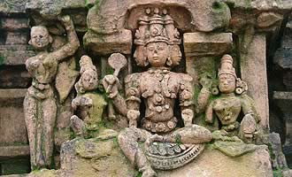
Brahma, Tanjore
Practiced primarily in India, Bangladesh, Sri Lanka and Nepal, Hinduism is considered the world's oldest religion, with traditions originating in and before the Neolithic era, around 8,000 years ago. Hinduism may have had its beginnings in the Indus River Valley in modern Pakistan, and the word hindu comes from the Persian name for that river.
A heterogeneous philosophy, Hinduism has no one founder and includes many sacred texts, the most ancient being the Vedas. Among the variety of genres included in the Vedic texts, composed 1500 – 1100 BCE, are hymns to gods, descriptions of rituals and philosophical writings. Commentaries on the Vedic books, written between 800 and 100 BCE, discuss the transcendent principal of Brahman, the source of the universe. Also influential are the great epics of the Mahabharata and Ramayana written between 500 BCE and 200 CE. Among these epics, the Bhagavad Gita describes the central idea of moksha, or liberation of the soul from the cycle of perpetual death and rebirth. The primary principle of karma determines the character of the soul in this cycle.
Ganges River
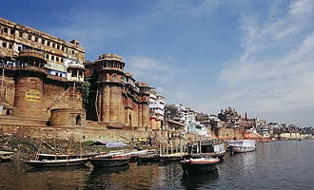
Ganges River at Varanasi

The river has played a vital role in the growth of the civilizations that developed along its shores, not only in terms of agriculture but commerce as well, and been worshipped by Hindus since ancient times. According to Hindu mythology, the Ganges is a goddess, Ganga, who dwelled in the heavens until a human king, Bhagiratha, prayed to the god Brahma to have her descend to Earth. Bhagiratha made this request in order to help cleanse and release the souls of his ancestors who had been burnt to death and condemned to wander in the nether-world. Although Brahma granted Bhagiratha's wish, Ganga was displeased and threatened to descend with such force that it would destroy the Earth. Bhagiratha then prayed to the god Shiva, who caught Ganga in his hair and released her in small streams to the Earth.
Varanasi
The holiest of India's sacred cities, Varanasi's mythical status within Hinduism has attracted religious seekers and pilgrims since antiquity. Previously known as Benares and Kashi ("city of light"), the abode of the Hindu god Shiva, Varanasi is referenced in the Vedas and the Mahabharata. Hindus believe that dying in the city will liberate them from the cycle of death and rebirth. Its present name derives from the two rivers, Varuna and Asi, that join the Ganges River here and the city is the most celebrated pilgrimage, destination in India.
Varanasi's waterfront, with its miles of ghats, is the spiritual heart of the city that is home to hundreds of shrines, temples, and palaces. Its famous sites include the Vishvanath Temple, dedicated to Shiva; the Durga Temple, with its throngs of resident monkeys; the Sankat Mochan, a shrine to the monkey god Hanuman; and the Gyanvapi Mosque built by the Mughal emperor Aurangzeb on the site of an earlier Shiva temple. Several miles north of Varanasi is Sarnath, where the Buddha preached his first sermon. Apart from its religious significance, Varanasi has been a center of learning—notably Sanskrit studies—and trade, and is known for its silk saris decorated with elaborately brocaded borders.
Magh Mela
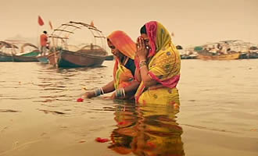
Pilgrims bathing in Ganges River
The annual festival held in Allahabad, formerly called Prayag, where three sacred rivers meet: the physical Ganges and Yamuna rivers are said to be joined here by the invisible, heavenly Saraswati River. This confluence is known as the Triveni Sangam and it is where, according to Hindu legend, Lord Brahma (the God of creation) performed the first fire sacrifice.
The location is considered especially auspicious during the Hindu month of Magha (January to February) on the day of the full moon and the new moon. Each year during this time, thousands of pilgrims travel to the city to take a ritual bath in the confluence to wash away their sins and increase their chances for salvation. In addition, they perform pujas (religious rituals), meditate, and mingle and listen to the addresses of Hindu holy men. A temporary tent city emerges on the river's banks to accommodate the faithful.
HIGHLIGHT ALL LINES THAT YOU FEEL ARE ESSENTAIL COMPONENTS OF HINDUISM.

