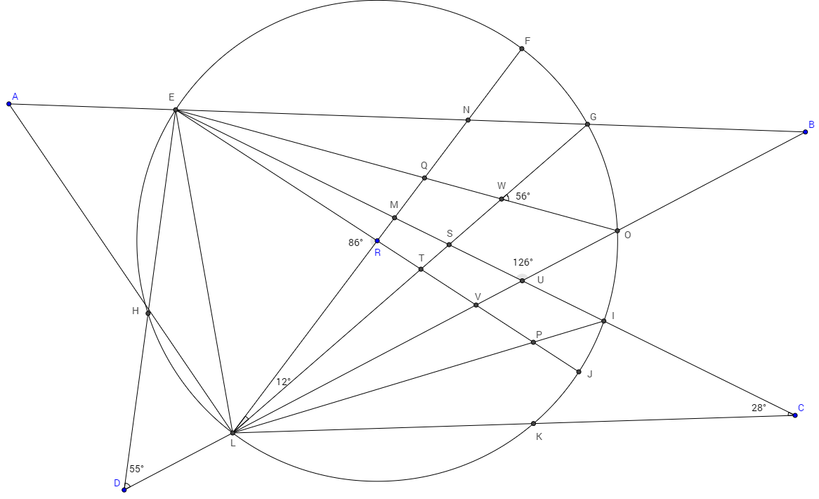
Solve The Blue Jay! Calculate every angle and every arc. Name _________________________
You will need to use many rules covering triangles, quadrilaterals, inscribed angles, central angles, and secants. DO CALCULATIONS ON ANOTHER PAGE, AND USE PENCIL!!

