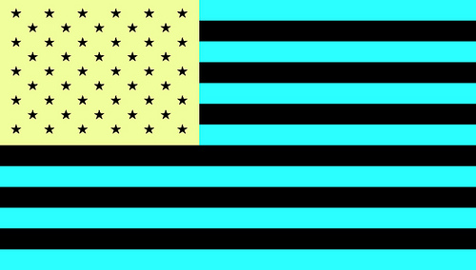
Stare at the diamond in the middle of the flag for twenty seconds. Tire out those cones!
Then stare at the diamond in the white space below the flag. Don’t move your eyes!

