See, Think, Wonder – Nomenclature (chemical formula naming) Routine 2
Names of Group members: _____________________________________________________________________ hour _____________
Look over the table that shows some chemical formulas and their names. What do you See? What does it make you Think? (can you find any patterns? Etc). What does it make you Wonder?

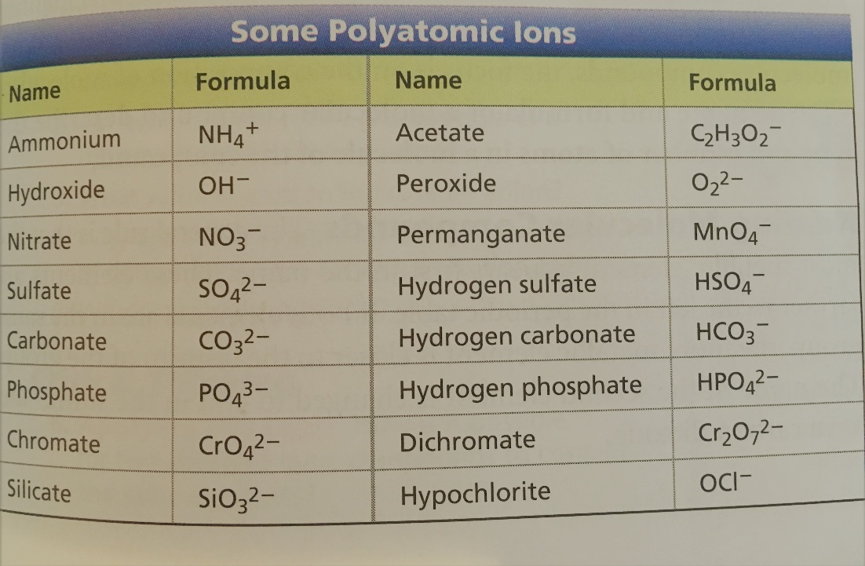
See?

Think?
Wonder?

See, Think, Wonder – Nomenclature (chemical formula naming) Routine 2
Names of Group members: _____________________________________________________________________ hour _____________
Use what you “saw” and “thought” to name the compounds below:

- CaCO₃ ________________________________________

- PbSO₄ _________________________________________

- NaOH _________________________________________

- KMnO₄ ________________________________________

- NH₄NO₃ ________________________________________

- H₂O₂ __________________________________________

