Class/Subject: Philosophy | Lesson 40: Logical Arguments
Objective(s): SWBAT create cogent, logical arguments using the framework and vernacular provided to them. | Unit- “LOGIC”
Philosophical Quote of the Day:  “He who establishes his argument by noise and command shows that his reason is weak”. -Michel de Montaigne | Philosophical Video of the Day:  Monty Python’s Argument Clinic: https://www.youtube.com/watch?v=ohDB5gbtaEQ
Key Points of the Day:  Premise: Proposition used as evidence in an argument.  Conclusion: Logical result of the relationship between the premises. Conclusions serve as the thesis of the argument.  Argument: The assertion of a conclusion based on logical premises.  Syllogism: The simplest sequence of logical premises and conclusions, devised by Aristotle. | Enthymeme: A shortened syllogism which omits the first premise, allowing the audience to fill it in. For example, "Socrates is mortal because he is a human" is an enthymeme which leaves out the premise "All humans are mortal."  Induction: A process through which the premises provide some basis for the conclusion.  Deduction: A process through which the premises provide conclusive proof for the conclusion.
Journal Entry:  Define the following terms: Premise, Conclusion, Argument, Syllogism, Induction, Deduction, and Reductio ad Absurdum | Featured philosopher and supplemental reading: Michel de Montaigne- Essais (1580)  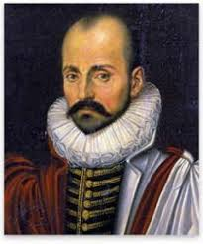Michel de Montaigne was one of the most significant philosophers of the French Renaissance, known for popularizing the essay as a literary genre.

