Pelvic cavity
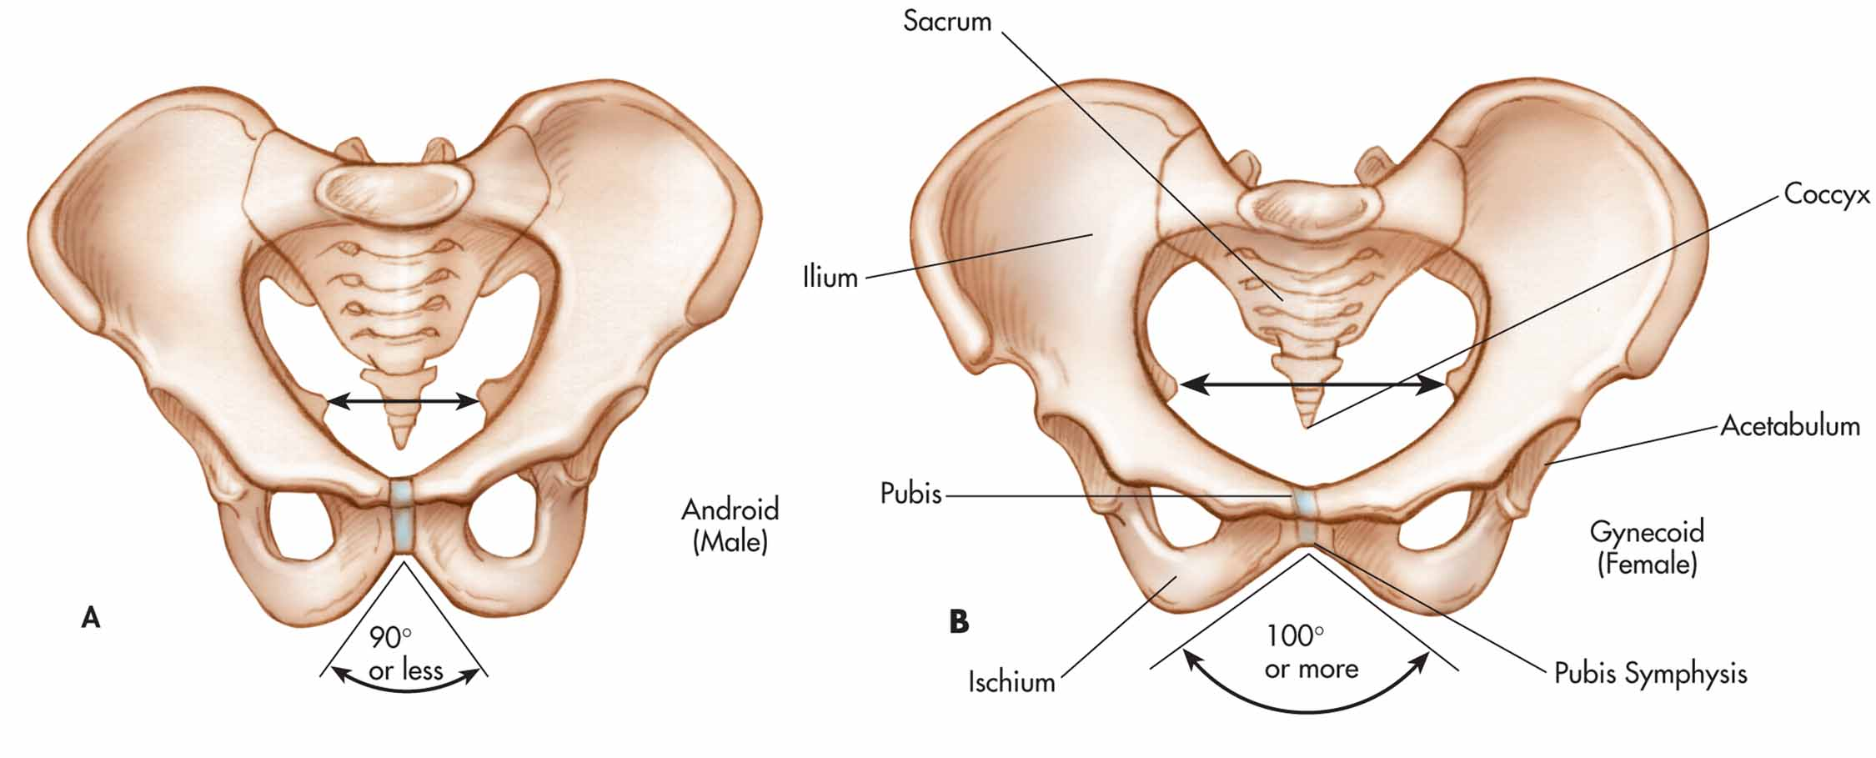

Pubic arch or angle

https://www.google.com/url?sa=i&source=images&cd=&cad=rja&uact=8&ved=2ahUKEwiIjf6J6ejhAhVKYKwKHRl-AIAQjRx6BAgBEAU&url=https%3A%2F%2Fsocratic.org%2Fquestions%2Fhow-are-the-male-and-female-pelves-different&psig=AOvVaw03FgmE6HmECz2BuO6nJxxk&ust=1556198242104982

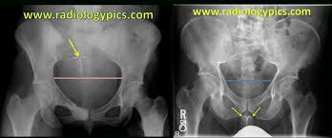
Female Male

https://www.google.com/url?sa=i&source=images&cd=&cad=rja&uact=8&ved=2ahUKEwjqi6HK6ejhAhUOQ60KHVBsAFwQjRx6BAgBEAU&url=https%3A%2F%2Fhumananatomylib.com%2F12-male-pelvic-bone-vs-female-pelvic-bone%2Fmale-pelvic-bone-vs-female-pelvic-bone-and-the-differences-between-the-male-and-female-pelvis-radiologypics%2F&psig=AOvVaw03FgmE6HmECz2BuO6nJxxk&ust=1556198242104982
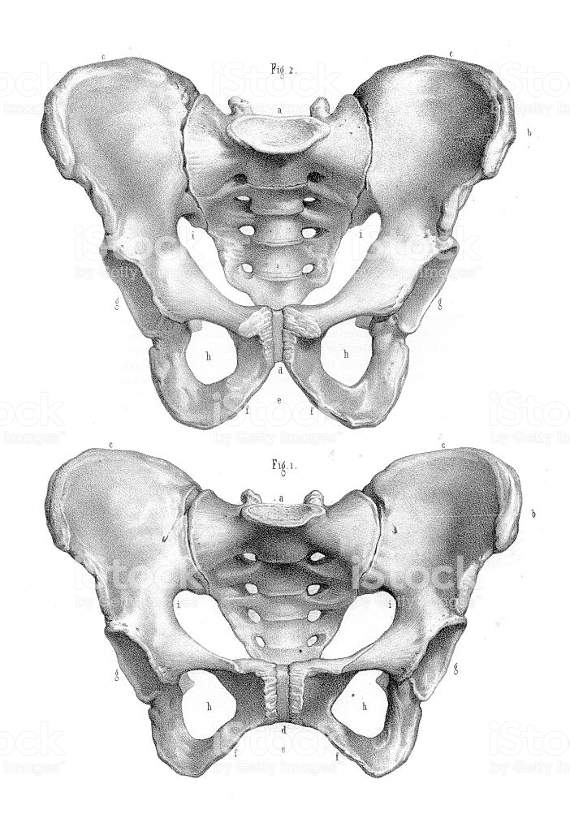
Male
Female
Sacrum
Ilium

