Lesson 29: Ethics and Your Political Philosophy
A very common application to use philosophical thought is in the realm of politics. Today we will explore the roots of our political ideals. Where do you stand on the various fiscal and social political issues down below?
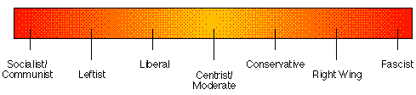

First of all, click on the link, http://www.gotoquiz.com/politics/political-spectrum-quiz.html. Take it and evaluate whether you feel the results are accurate.
Often times people label and place themselves in such categories as a means of group affiliation and a means of codifying their epistemic paradigm.
Here are the political issues we will address:
1) Affirmative Action- Ethical or unethical? Does it depend on what institution it relates to?
2) Separation of Church and State- Meaning of religious freedom, prayer in school
3) Criminal Justice Issues- Retribution vs. Rehabilitation? How incarcerated people should be treated?
4) Opiate Epidemic- What should we do about it, if anything?
5) Educational Policy- How should schools be funded/structured?
6) Immigration Requirements/DACA-
7) Net Neutrality/Internet Issues-
8) Gun Control- 2nd Amendment’s meaning/School shootings
9) Civil Rights Issues- Race relations/LGBTQ issues
10) Budget- Where should America’s money be allocated?

