See, Think, Wonder – Nomenclature (chemical formula naming) Routine
Names of Group members: _____________________________________________________________________ hour _____________
Look over the tables and charts that show some chemical formulas and their names. What do you See? What does it make you Think? (can you find any patterns? Etc). What does it make you Wonder?
Binary Ionic compounds

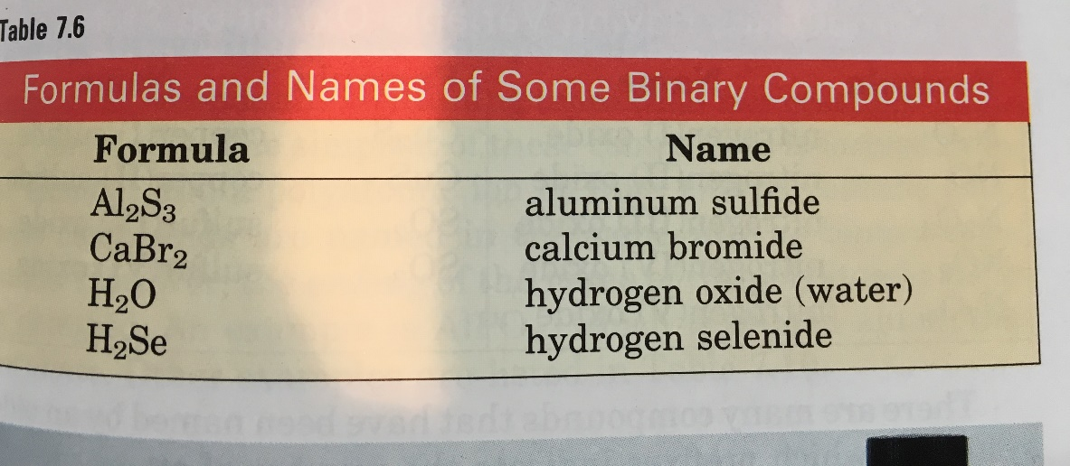
See?

LiBr
Lithium Bromide
KF
Potassium Fluoride

Think? Wonder?

Binary Molecular Compounds
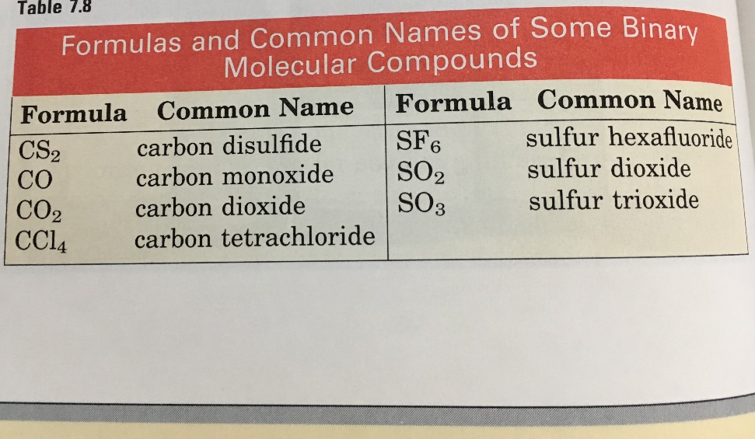
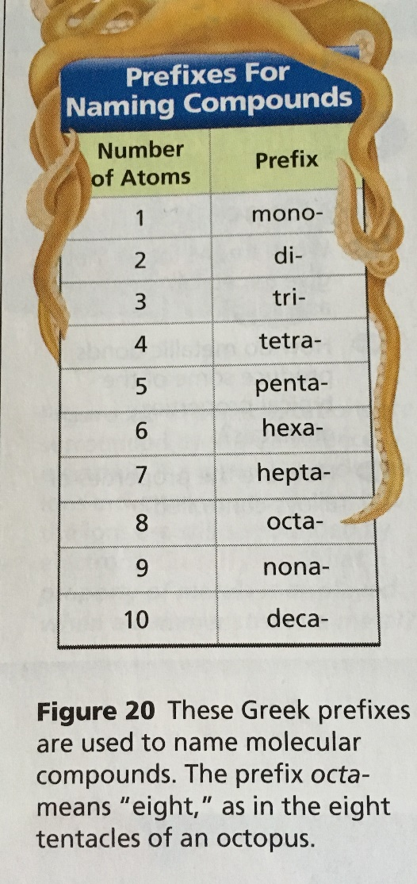
See?

Think?

Wonder?
Compounds with varied oxidation states
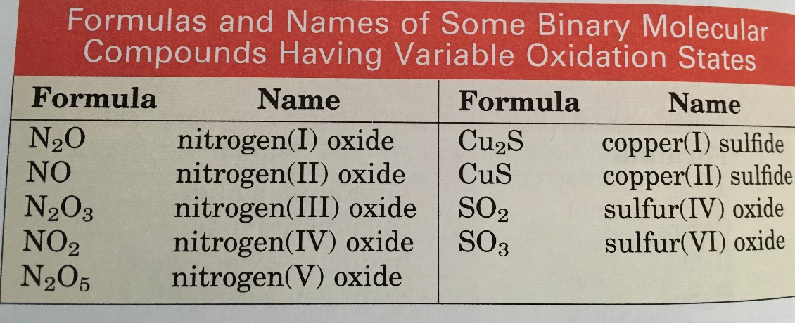
See?

Some examples of metals with varying oxidation
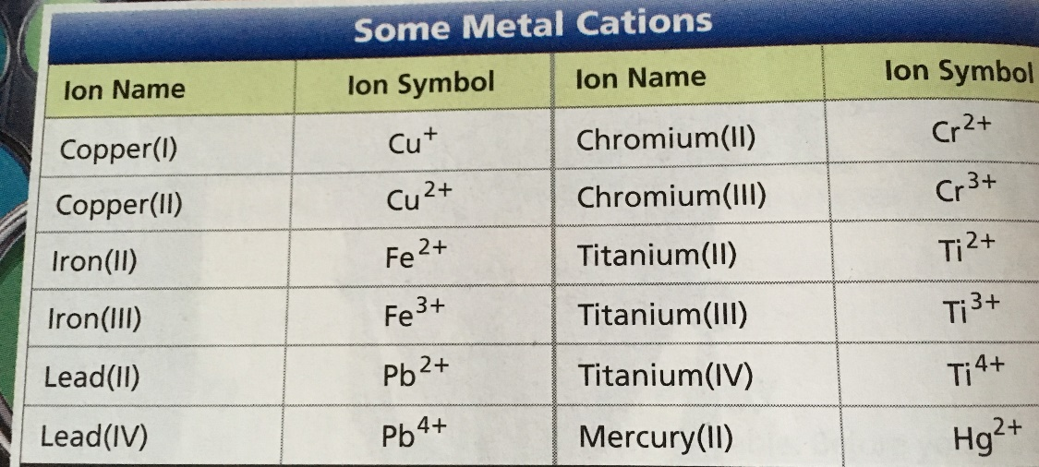
Think?

Wonder?
See, Think, Wonder – Nomenclature (chemical formula naming) Routine
Names of Group members: _____________________________________________________________________ hour _____________
Use what you “saw” and “thought” to name the compounds below:

- MgF₂ _____________________________

- FeCl₂ ______________________________

- NaCl ______________________________

- PBr₅ ______________________________

- Cu₃P ______________________________

- SeF₆ _______________________________

