Day 160: End of the Cold War Web Form
On your large paper recreate this web form with the following events listed below:
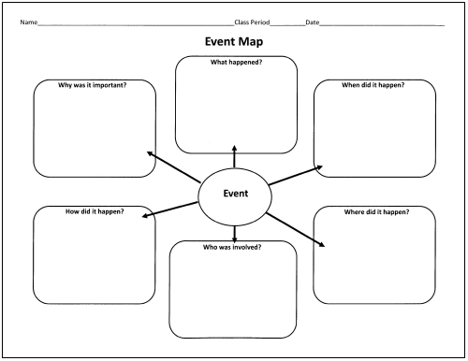
- Solidarity Movement in Poland (Lech Walesa): PAGES 1003-1004

- Glasnost and Perestroika (Mikhail Gorbachev): PAGE 1002

- The Split of Czechoslovakia (Václav Havel): PAGE 1004

- The Berlin Wall Falling (November 9, 1989): PAGE 980

