Map of Africa

Name: ____________________ Hour: _______________________

- Using technology and/or your textbooks (pg. 1136), fill in the map of Africa below with the names of the modern countries, and use colored pencils to color in the Sahara (brown) and the Senegal, Niger and Benoue Rivers (blue).

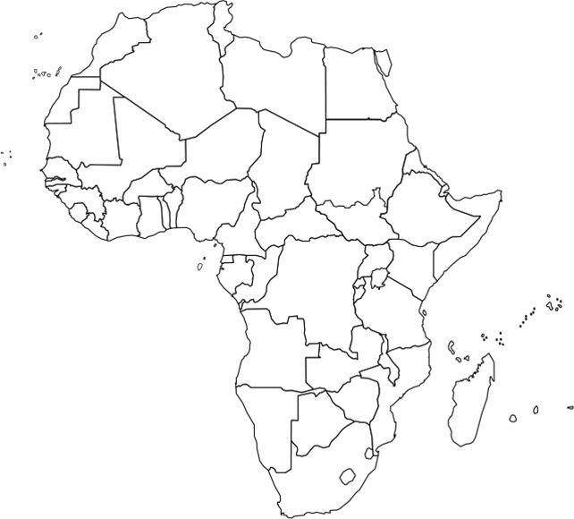

2) After you have found all the countries, find and label the following cities:
- Cairo (Label this Mansa Musa! SALT!)
- Djenne: (Label or draw a picture for GOLD!)
- Ghat: (Label or draw a picture for SALT!)
- Zaria: (Label or draw a picture for GOLD!
- Mopti: (Label or draw a picture for GOLD!)
- Sijilmassa: (Label or draw a picture for SALT!)
- Timbuktu: (Label or draw a picture for GOLD! TRADING HUB)

3) What direction did trade for Gold and Salt run? Why would these commodities be important?

4) Theorize why Islam was so prevalent in the region? What effect would it have on African culture?

