Mobilization of the War Effort

Selling war bonds to raise money

Food and energy rationing
Growing victory gardens
Increasing working hours
Increasing taxes
Prohibiting strikes in war-related industries
Converting factories to war-related production, such as Ford producing tanks and bombers instead of cars
Women working in jobs outside the home and previously held almost exclusively by men
African Americans gaining access to better pay and jobs
Recycling campaigns

Propaganda Posters: Germany and the Soviet Union
Poster 1 Poster 2
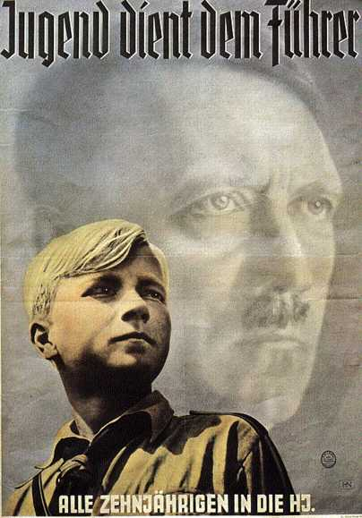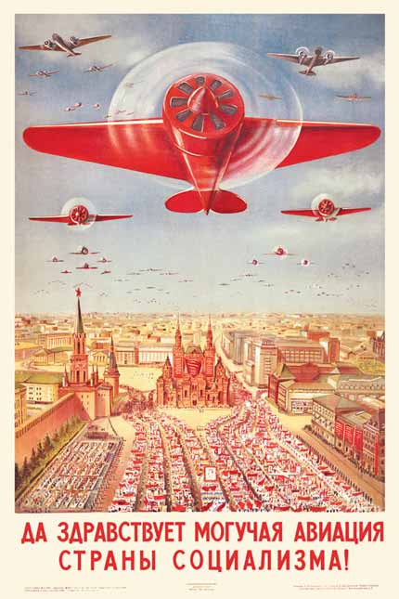
Youth serves the Fuhrer
Source : http://www.calvin.edu/academic/cas/gpa/posters/hj.jpg

“Hail to the powerful air force of the country of socialism”
Source: http://www.cccpfashion.com/posters/CCCP-USSR-Poster1.jpg

Propaganda Posters: Women During WWII

Poster 3 Poster 4 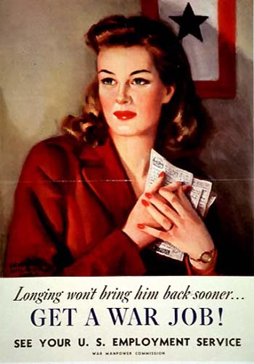
Rosie the Riveter
From: http://www.archives.gov/exhibits/powers_of_persuasion/its_a_womans_war_too/images_html/longing.html

Source: http://www.archives.gov/exhibits/powers_of_persuasion/its_a_womans_war_too/images_html/we_can_do_it.html

Propaganda Posters: Minorities

Poster 5 Poster 6
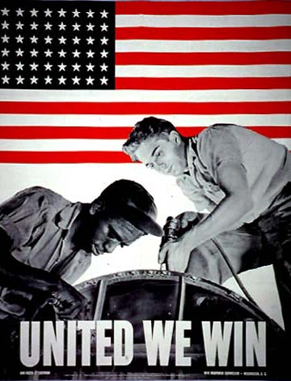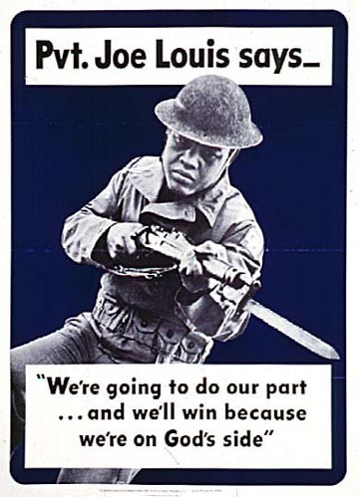
From: http://www.archives.gov/exhibits/powers_of_persuasion/united_we_win/images_html/private_joe_louis_says.html

From: http://www.archives.gov/exhibits/powers_of_persuasion/united_we_win/images_html/united_we_win.html

Propaganda Posters: General Propaganda and Individual Efforts

Poster 7 Poster 8
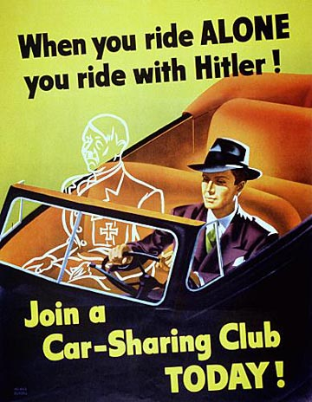

From: http://www.archives.gov/exhibits/powers_of_persuasion/warning/images_html/our_homes_in_danger.html

From: http://www.archives.gov/exhibits/powers_of_persuasion/use_it_up/images_html/ride_with_hitler.html

Propaganda Posters: Labor Unions and Individual Efforts
Poster 9 Poster 10
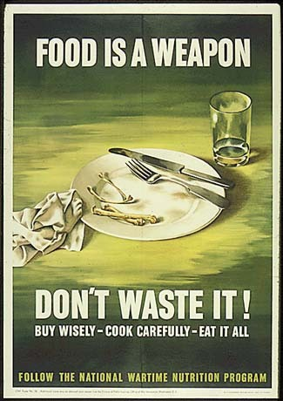
From: http://history1900s.about.com/library/photos/blywwiip108.htm

From: http://www.archives.gov/exhibits/powers_of_persuasion/stamp_em_out/images_html/crack_the_axis.html

Poster 11
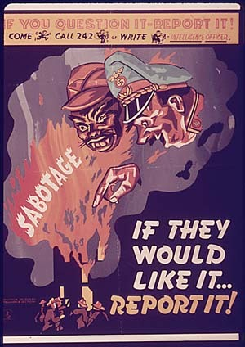
From: http://history1900s.about.com/library/photos/blywwiip149.htm

